LESSON – 2D MEASUREMENT REVIEW

GUIDED PRACTICE: 2D MEASUREMENT– RECTANGLES + SQUARES

PERIMETER = Distance __________________ object. Unit = __________________

AREA = Space ____________________ object. Unit = _____________________

Shape name: |  |  | Formulas:
Example:  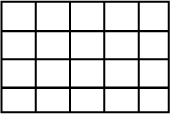 |  | Example:  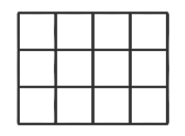

Shape name: |  |  | Formulas:
Example:  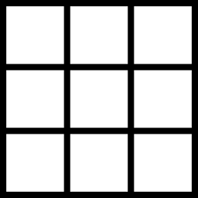 |  | Example:
GROUP PRACTICE: 2D MEASUREMENT REVIEW
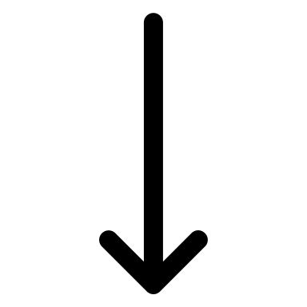
Locate the following 2D shapes in the classroom or nearby. Obviously, objects are 3D, so select one face of the object to study. WORK YOUR WAY DOWN, SHOWING
FORMULA
WORK
ANSWER (WITH UNITS)
- TASK 1: RECTANGLE
Object: ___________________________. Sketch it with metric dimensions ↓
Perimeter Calculation:

Area Calculation:

- TASK 2: SQUARE
Object: ___________________________. Sketch it with metric dimensions ↓
Perimeter Calculation:

Area Calculation:

