GUIDED REVIEW: 2D MEASUREMENT - TRIANGLES

Shape name: |  |  | Formulas:
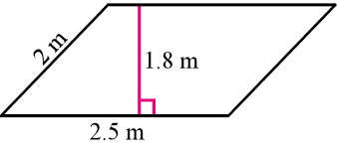  Example: |  | 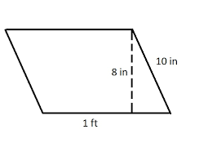  Example:

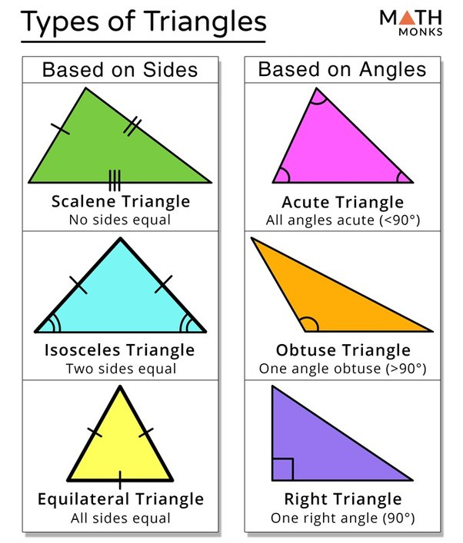 |  | Formulas:

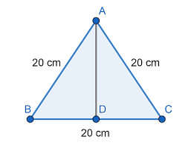  Example:  17.32cm  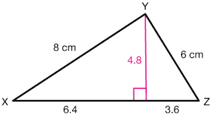  A = 24 cm² | Example:  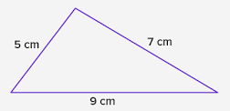  4 cm  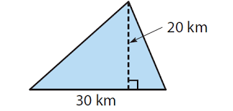  A = 300 km²

Next class we’ll learn what to do if we’re not given the area or perimeter as well as another measurement! It’s kind of tricky!
TASK 1 - PRACTICE: 2D MEASUREMENT: TRIANGLES
Complete worksheet. Check once solutions are posted that you’re on the right track.
TASK 2 - PRACTICE: 2D MEASUREMENT: TRIANGLES
Find a triangle in the classroom or nearby. Obviously, objects are 3D, so select one face of the object to study. Sketch it and include its dimensions as you’ve measured (metric to nearest tenth of a cm; imperial to nearest $1/{16}$ of an inch). Complete this on the back of the above worksheet.
GUIDED PRACTICE: 2D MEASUREMENT– TRIANGLES WITH “MISSING” MEASUREMENTS

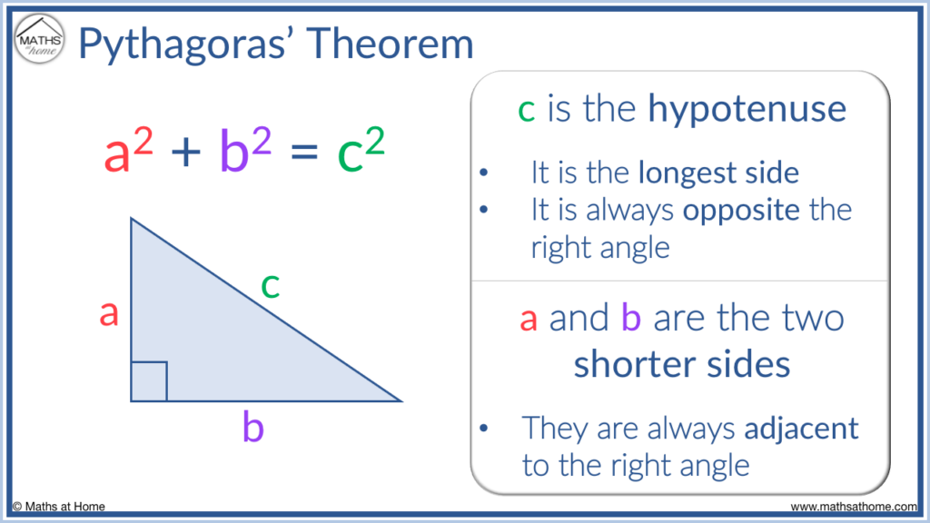
Proof activity

Ex: find missing leg, then find A and P  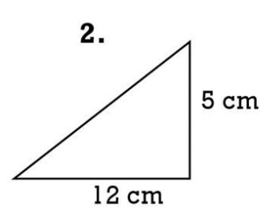  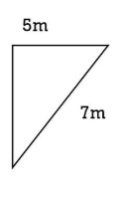 | Ex: find missing leg, then find A and P  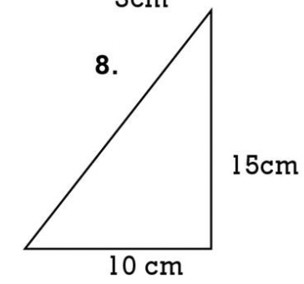  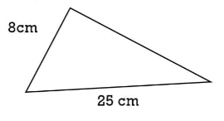

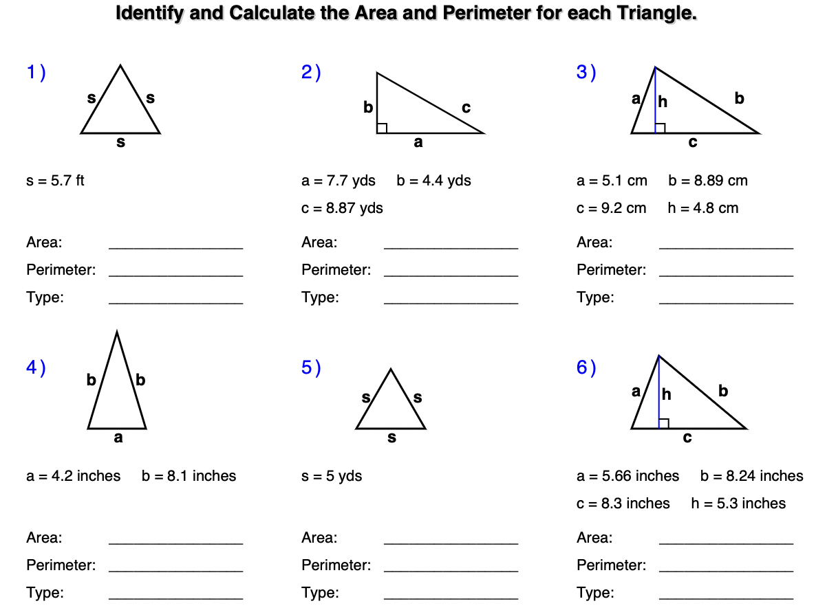

7) Two joggers run 8 miles north and then 5 miles west. What is the shortest distance, to the nearest tenth of a mile, they must travel to return to their starting point?

8) Oscar's doghouse is shaped like a tent. The slanted sides are both 5 feet long and the bottom of the house is 6 feet across. What is the height of his doghouse, in feet, at its tallest point?

9) A suitcase measures 24 inches long and the diagonal is 30 inches long. How much material is
needed to cover one side of the suitcase?

10) Find a third number so that the three numbers form a right triangle:
- 9 , 41 ii). 13, 85

