Sc9 Notes UNIT – REPROUCTION Name: ________________
Big Idea: Cells are derived from cells
THE NUCLEUS & DNA
- Nucleus is the __________________________________ of a living cell
- Surrounded by _______________________________________ (kind of like cell membrane).
  - Function: ________________ contents of nucleus
- Inside is membrane-free ____________________________
  - Function: make _______________________, whose job it is to make proteins
- Has small openings in nuclear membrane called ___________________________
  - Allow certain things in/out of nucleus (ex. Ribosomes).
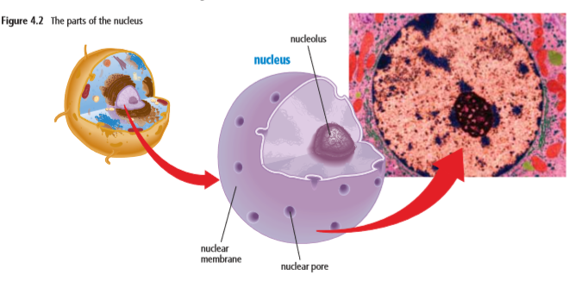
- The nucleus contains the master set of ___________________ that determines what each cell will become, how it will function, when it will grow and divide, and when it will die
- The instructions in the nucleus are carried in long, two-stranded molecules called
____________________________________________________, or DNA.

- The DNA molecule looks like a twisted ___________________
- The two strands, or sides, of the DNA ladder wrap around each other in a spiral
shape that scientists call a _____________________________________
  - The word “helix” comes from a Greek word meaning to wrap.
- The sides of the DNA ladder are made of _____________________ and
_________________________.
- The steps of the ladder are made of four __________________________ bases, which are represented by the letters: A (adenine),G (guanine), C (cytosine), and T (thymine)
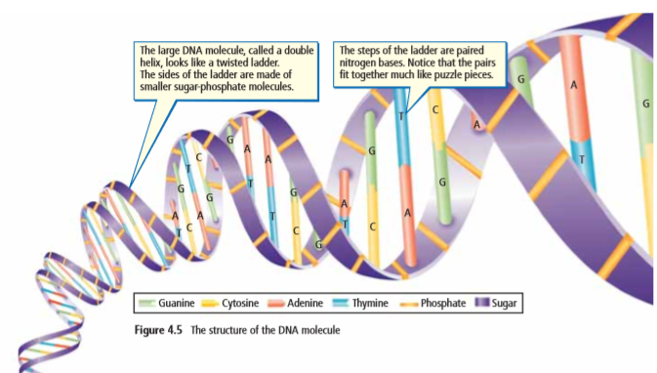
DNA Arrangement
- Everything that occurs within a cell is the result of how the bases on the DNA molecule are arranged This arrangement is known as the ______________________
- Bases in a DNA molecule always join in a specific way:
  - A always joins with ______
  - G always joins with ______
- However, the _________________ and _____________________ of these bases can vary greatly within the DNA molecule. In humans, a single DNA molecule can be several million base pairs in length.
How is DNA stored?
- DNA exists in the nucleus in the form of ______________________________
  - Chromatin is a substance that contains __________ and _____________________
- Within each strand of chromatin is one molecule of DNA
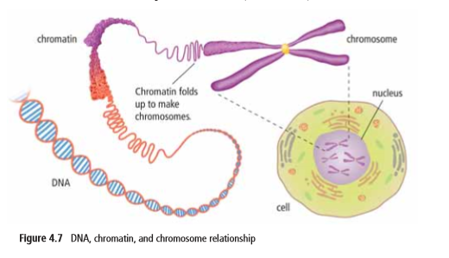
- When a eukaryotic cells is ready to divide, each strand of chromatin coils up into a very compact, X-shaped structure called a ___________________________

- Chromosomes within the nucleus are found in ________________
- Most human cells have ______ chromosomes arranged in _________________, including one pair of chromosomes that help determine sex.
  - In biological males, the 23rd pair of chromosomes is the ____________ pair.
  - In biological females, it is the ______________ pair.
  - Every living thing has a characteristic number of chromosomes
- _________________ are small segments of DNA located at specific places on a chromosome
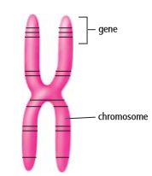
- Genes store the information needed to produce 90 000 to 100 000 different proteins used in the cells of your body.
- The arrangement of ______________ in a gene will usually be used to produce a specific protein.
- Genes can vary in length from hundreds to thousands of bases.
- Every chromosome carries thousands of genes and therefore contains the information to make thousands of different proteins.

