Sc9 Notes Chem Unit – Spindlove Name: ______________
INVESTIGATING MATTER
Describing Matter

- Matter is anything that has _____________ and ________________

- Matter can be described by its ______________________

Physical Properties:
- can be _________________ or _________________ without changing the identity of the substance

Chemical Properties:
- describe a substance’s ability to ________________________________ with other substances to form new products.

PHYSICAL PROPERTIES
Two categories:
  - Qualitative properties: _____________ but not measured; ______________

  - Quantitative properties: measured _________________

>>>> Refer to ongoing Properties List <<<<

Changes in Matter
- Matter can undergo 2 types of changes:
- Physical change: the ___________ of matter may change but _____ chemical bonds are broken or made and ______ new substance is formed
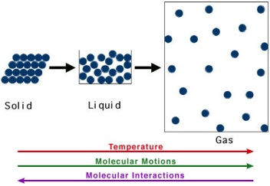
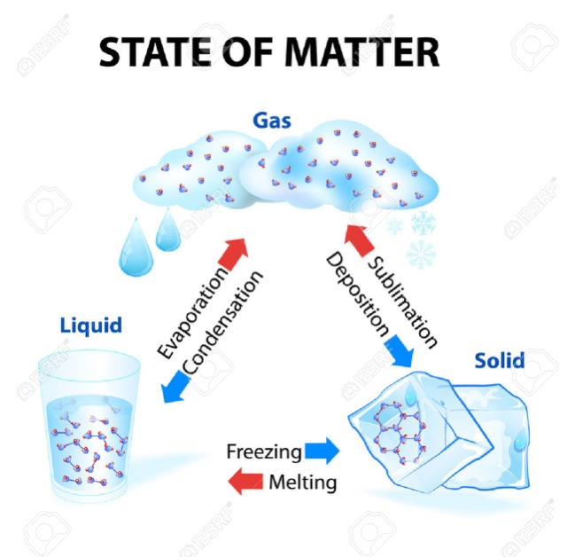
Changes of state depend on factors such as ___________________
When heat is added to a substance, its particles ___________ kinetic energy and move __________, causing them to move ____________ apart

KMT

- Chemical change: occurs when substances combine to form _________ substances

Evidence of Chemical Change:

- _____________________________________________________
- _____________________________________________________
- _____________________________________________________
- _____________________________________________________
- _____________________________________________________

