Sc 9 Notes Chem Unit COMPOUNDS Name:___________________
- A compound is a pure substance made up of _________________________________________ kind of element in which the atoms of the elements are joined together.
- By combining in elements, compounds can for more _____________________ substances
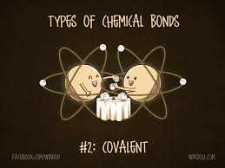
- Compounds form through ____________________________, which are links between 2 or more atoms that hold the atoms together
- Two basic types of compounds:
  - ___________________________ compounds
    - ___________________________ + non-metal
    - Electrons are _______________________
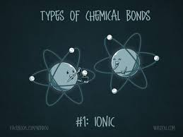
  - ___________________________ compounds
    - _________________________ + non-metal
    - Electrons are ________________________

We can use various lab tests to determine if an unknown compound is ionic or covalent:
- _____________________ Test
  - Ionic: _____________________________________________________________
  - Covalent: __________________________________________________________

- _____________________ Test
  - Ionic: _____________________________________________________________
  - Covalent: __________________________________________________________

- _____________________ Test
  - Ionic: _____________________________________________________________
  - Covalent: __________________________________________________________

- _____________________ Test
  - Ionic: _____________________________________________________________
  - Covalent: __________________________________________________________

