PreIBSc 9 Notes Chem Unit - Spindlove
IONIC COMPOUNDS – INTRO

- Atoms gain or lose electrons to form _____________
- An ionic compound forms when electrons on metal atoms _______________________ to a non-metal atoms, creating _______________________ charged ions
Example: table salt: Na + Cl
- When sodium and chlorine atoms come together, they are electrically _____________________
- When they get close enough, an electron transfers from the sodium to the chlorine (recall that
sodium has an _________________ electron in its valence shell & chlorine is ______________ one)
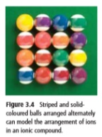
- This makes a positive sodium ion, Na⁺, and a negative chlorine ion, Cl⁻.
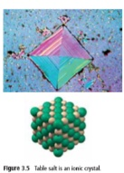
- Ionic compounds exist as a solid in the form of an ______________________________
  - A repeating pattern of positive and negative ions

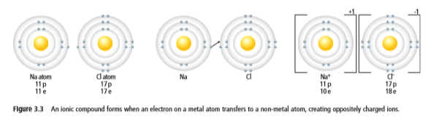
Drawing ionic compounds Example: Sodium chloride (NaCl)

Drawing ionic compounds Example: Magnesium fluoride (MgF₂)

NAMING COMPOUNDS
- A chemical name indicates the ____________________ present in the compound
- The chem name of an ionic compound has two parts: one for each type of ion in it.
  - 1st part names the ____________________ ion (called the cation)
    - The positive ion is always a _____________________ in a compound containing 2 elements
  - The 2nd part names the ___________________ ion (called the anion)
    - The negative ion is always a __________________________ in a compound containing 2 elements
    - The non-metal ion’s name always ends with the suffix __________
Examples:
- MgBr₂ __________________________________  - Ag₃N ___________________________________ | - Sr₃P₂ __________________________________  - Na₂O __________________________________
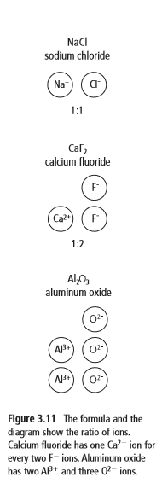
CHEMICAL FORMULAS
- Contains __________________________ to identify each ion
- Shows the relative numbers of _______________ in the compound (ie. ratio)
  - shown as a _________________________ to the right of the element symbol
- In an ionic compound the positive charges __________________ the negative charges

How to Write Chemical Formulas of Ionic Compounds
- Step 1: Put ________________________ of each element together.
Leave a tiny space between for any subscripts
- Step 2: Figure out _____________________ needed to balance the charges on the metal and non-metal (how many of each do you need?)
- Step 3: Include ________________________ to the right of each element. If there is “1”, do not include that.
Note: NO charges should appear in a compound. Compounds are neutral!!

Example: Zinc nitride Example: Magnesium chloride

Shortcut…
Zinc nitride | Magnesium chloride | Calcium oxide | Tin oxide

