NAMES & FORMULAS OF IONIC COMPOUNDS
Part A: Naming Compounds
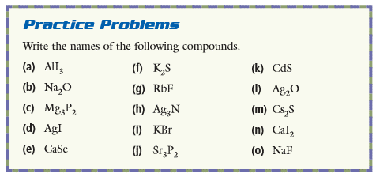

(a)
(b)
(f)
(g)
(k)
(l)
(c)
(d)
(e)
(i)
(j)
(m)
(n)
(o)
(Ex in notes)
Complete on your own as practice
Done in class, check posted solutions!
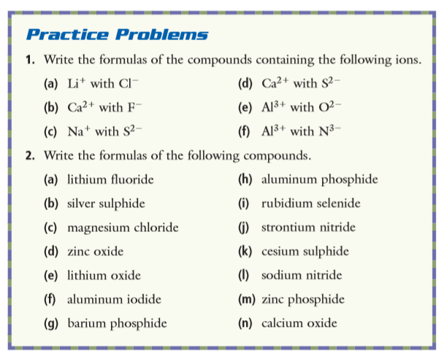
Part B: Writing Formulas

1. |  | d)
 | b) | e)
 | c) | f)
2. |  | h)
 | b) | i)
 | c) | j)
 | d) | k)
 | e) | l)
 | f) | m)
 | g) | n)

Done in class, check posted solutions!

Complete on your own as practice

