Science 9 Notes Name: ____________________________
MEASUREMENT - VOLUME
Volume is the amount of _____________________ taken up by an object or substance.
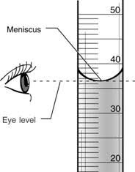
Liquids:
Volume is commonly measured with a _____________________________
Units for liquid volume is ____________________, typically ________
When reading from a graduated cylinder, we read from the ___________ of the curved water line. This is called the _________________.
Be sure to be _______________________ with the meniscus to obtain an accurate measurement.
A graduated cylinder can have numerous ________________ so be sure to determine the value of each of the gridlines prior to taking your measurement.
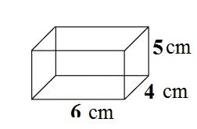
Solids (“regularly” shaped):
- Volume is measured with a ________________ and calculated (l x w x h)
- Units for solid volume are __________________, typically ________
Ex: Vol = ______ x ______ x ______ = _________
Solids (“irregularly” shaped):
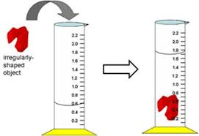
      - Volume is measured by __________________________________
Steps:
        - Add water to graduated cylinder and record volume of water (must be enough to completely cover object).
        - Add item to the cylinder. The water level will rise.
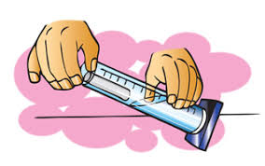
        - Record the new water level.
        - __________________ the two volumes. This is the volume of the object.
Be sure to think through the size of the object you are using and ensure you have an appropriately sized cylinder so it does not become stuck!
Solids are typically measured in _______. You will be measuring the water level in ________…

