Sc9 Notes Chem Unit Name: ____________________
IONIC COMPOUNDS WITH MULTI-VALENT METALS
- Many important metals are multivalent
  - “multi” means many
  - “valent” refers to the capacity to bond

- Multivalent metals can form ___________________ different __________________ ions with different ion charges
  - Ex: Iron has 2 ion charges: __________ and __________. It can exist as either.
- Periodic table shows the most ___________________ ion charge first
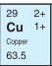
- When we’re talking about multivalent metals (ONLY!), we need make sure we’re clear which
ion form we’re talking about. To do this, we use ____________________________________
  - We ______________ use Roman Numerals for copper (Cu) because it can have a charge
of either 2+ or 1+ as an ion, and we’d need to specify which one
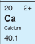
  - We _______________ use Roman Numerals for calcium (Ca) because it always has a
charge of 2+ as an ion
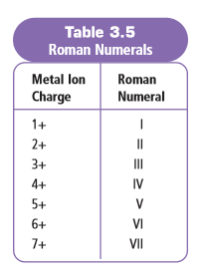
Examples
Fe³⁺ - Written: _____________________ ; pronounced : “iron three” ; means the iron ion has a charge of 3⁺
Fe²⁺ - Written: _____________________ ; pronounced : “iron two” and means the iron ion has a charge of 2⁺
Pb⁴⁺ - Written: _____________________ ; pronounced : “lead four” and means the lead ion has a charge of 4⁺
Cu⁺ - Written: _____________________ ; pronounced : “copper one” and means the copper ion has a charge of 1⁺

Writing Chemical Formulas with Multivalent Metals
- The _________________________ after the metal will tell you which ion charge to use
  - Example: chromium(III) fluoride ________________
Examples: Write the chemical formulas of the following compounds
- copper(I) iodide ________________  - tin(II) nitride _________________ | - iron(II) phosphide ______________  - tin(IV) nitride __________________

Naming Compounds with Multivalent Metals
- It’s important EVERY time you write the metal in the compound, you stop to _______________ if it’s multivalent!!
  - If it IS, you need to include the __________________________________
  - If it IS NOT multivalent, __________________ include Roman Numeral!
Examples: Write the name of the following compounds
- Cu₃P ________________________________
- MnO₂ ________________________________

