Science 9 Spindlove – Chem Unit Name: ___________________
BINARY IONIC COMPOUND ASSIGNMENT

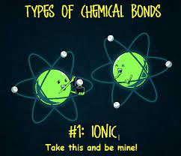
- Write the chemical formula for each binary ionic compound. Pay attention to which are multivalent!

  - Aluminum bromide ___________________
  - Potassium iodide ___________________
  - Tin(IV) nitride ___________________
  - Lithium sulphide ___________________
  - Nickel(II) sulphide ___________________
  - Manganese(IV) phosphide ___________________
  - Iron(III) bromide ___________________
  - Aluminum oxide ___________________
- Write the name for each binary ionic compound. Pay attention to which are multivalent!

- Ca₃N₂  - LiBr  - Cr₃N₂  - K₂S  - PbO₂  - CrF₂  - SnS₂  - Al₂O₃  - CuI  - MnS  - MgF₂ | _____________________________________________  _____________________________________________  _____________________________________________  _____________________________________________  _____________________________________________  _____________________________________________  _____________________________________________  _____________________________________________  _____________________________________________  _____________________________________________  _____________________________________________

