SCIENCE 9 – CHEMISTRY CUMULATIVE TEST OUTLINE
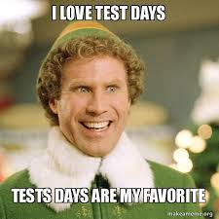
Format: Combo multiple choice + written. Skill development section is written.

SKILLS to know how to demonstrate:
- If given a data table with data, can you accurately graph it?
- If given a procedure, can you create a data table skeleton?

CONTENT to know:

COMPOUNDS
- Compare/contrast ionic vs covalent compounds  - Naming and writing simple ionic compounds  - Ex. Li⁺ + Cl⁻ LiCl , Lithium chloride  - Ex. Mg²⁺ + P³⁻ Mg₃P₂ , Magnesium phosphide  - Naming and writing multivalent ionic compounds  - Ex. MnO₂ Manganese (IV) oxide  - Ex. Chromium (II) sulphide CrS | - Naming and writing polyatomic ionic compounds  - Ex. Sodium carbonate Na⁺ + CO₃²⁻ Na₂CO₃  - Ex. Magnesium phosphate Mg²⁺ + PO₄³⁻ Mg₃(PO₄)₂  - Naming and writing compounds that include both multivalent and polyatomic ionic compounds  - Ex. Copper(II) sulphate Cu²⁺ + SO₄²⁻ CuSO₄  - Naming and writing covalent compounds  - Ex. Carbon tetrachloride CCl₄
PERIODIC TABLE
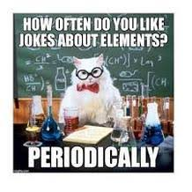
- What is the periodic table and approximately how many elements are identified? How are elements organized?
- Metals vs non-metals vs semi-metals (aka metalloids)
  - Location on table
  - Typical properties (table 2.2)
- Which direction does a period go? What does this tell us about electrons shells?
- Which direction goes a group go? What does this tell us about valence electrons?
- Name and location (group number) of the 4 chemical families. General reactivity.
- How to read a symbol: atomic number, atomic mass, ion charge
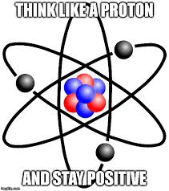
- Atomic structure: location (in atom) and charge of subatomic particles
  - Proton
  - Neutron
  - Electron
    - What are valence electrons?
- Bohr model
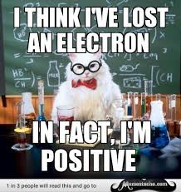
  - We use the Bohr model to understand probably location/spacing of electrons but it is NOT the most current model. What is the most current model called?
  - Draw the Bohr model of atoms
  - Draw the Bohr model of ions
- What is an Ion?
- Do metals lose or gain electrons? Do they form positive or negative ions?
Do they have a positive ion charge or negative ion charge? What about non-metals?
- Make a connection between valence electrons of atoms and ion charge of ions
- Why do noble gases not form ions?
MATTER
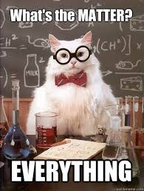
- What is matter?
- What are the two types of changes matter can undergo? Give/Identify examples
- What are the signs that a chemical change has occurred?
- KMT
  - What does KMT stand for?
  - What are the main points of the theory?
  - What is the relationship between temperature and the states of matter, with reference to the KMT? How would this look on a graph?
  - What is the relationship between molecular motion and the states of matter, with reference to the KMT? How would this look on a graph?
  - What is the relationship between molecular interaction and the states of matter, with reference to the KMT? How would this look on a graph?
- States of matter
  - What are the 3 states of matter? What are the 6 terms indicating change of state?
  - Connect the KMT to the 3 states of matter
  - What is needed to force a shift between the states?
- What are qualitative physical properties of matter? Give/Identify examples
- What are quantitative physical properties of matter? Give/Identify examples
- What are the two categories of matter? Give/Identify examples
- What are the three types of mixtures? Give/Identify examples
- What are the two types of pure substances? Give/Identify examples

MEASUREMENT
- What is mass?  - How is it measured (solids & liquids)? What are the units? | - What is volume?  - How is it measured (solids & liquids)? What are the units?  - What is the difference between accuracy & precision?

SAFETY
- General Lab Safety Rules (text p 10,11)  - HHPS  - What does it stand for?  - HHPS Symbols: types, shapes and levels | - WHMIS  - What does it stand for?  - WHMIS Symbols

SCIENTIFIC METHOD
- What are the steps of the Scientific Method?
- What does a good hypothesis have? Can you prove a hypothesis to be true or false?
- What are Control Variables? Why is it important to identify them?
- What is an Independent Variable? Can you identify it in a scenario? Which axis is it graphed on?
- What is a Dependent Variable? Can you identify it in a scenario? Which axis is it graphed on?
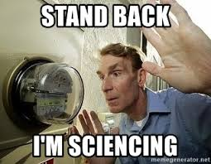
- Do experiments test multiple variables or only one? Why?
- What is qualitative data? Can you give/identify examples?
- What is quantitative data? Can you give/identify examples?
- When is a bar graph used versus a scatter graph?

