Sc9 Notes Chem Unit Name: ____________________
IONIC COMPOUNDS WITH POLYATOMIC IONS

- Covalent & ionic bonds can be found in the same compound!
- It is possible for some molecules (i.e. ____________________ ) to gain or lose electrons (__________________ bonding) as their atoms combine to form a molecule (___________________ bonding)
- In doing so, they become a molecular ion, called a ___________________________________.
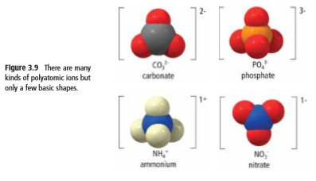

- Polyatomic ions often have ___________________ names, so if you do not see the word listed as an element on the periodic table, chances are it is a polyatomic ion so refer to the table of common polyatomic ions
- Because a polyatomic ion carries an electric charge, it __________________ exist on its own.
  - It is always paired up with ions that carry an ___________________ charge.
  - The charges need to cancel out. Compounds are _______________!!

Example : CO₃
- When carbon (non-metal) bonds with oxygen (non-metal), they form a ____________ bond
    - It takes 3 oxygen atoms and 1 carbon atom to create one molecule.
- Like many covalent compounds, it takes a common name, __________________
- CO₃ carries an electric charge of ________, so it ________________ exist on its own. It needs
to be paired up with a ____________ (because, +) to make the compound neutral

Part A: Writing Formulas of Compounds with Polyatomic Ions
Examples:
Sodium chromate Tin(II) hydroxide

Part B: Naming Compounds with Polyatomic Ions
Examples:
NaCH₃COO Cr(OH)₃ Ba₃(PO₃)₂

