Sc9 Chem Notes- Spindlove COVALENT COMPOUNDS Name: _______________
- Covalent compounds are made up of two _________________________.
- Covalent compounds ____________ electrons to form molecules. Example: __________
________________
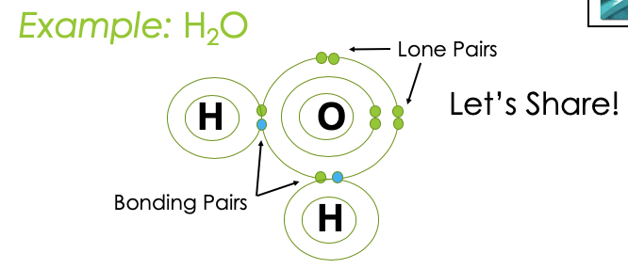
________________
Naming Covalent Compounds
- Binary covalent compounds – covalent compounds that contain only ______ elements — are named using a procedure similar to that used for simple ionic compounds, but use a _________ method as well.
  - Formulas show the ___________________ of atoms of each element in a molecule (e.g. H₂O₂)
    - NOT a ratio like ionic!
  - __________________ are used to show this
Step 1:  - Place the elements in their proper _________________.  - The first element farthest to the left in the periodic table is usually named first.  - If both elements are in the same group, the element closer to the bottom of the column is named | Step 2:  - _______________ each element in the compound the same way we do with ionic compounds.  - The 1st element name is unchanged  - The 2nd element name has suffix “ide” | Step 3:  - Identify the _________ of each type of atom present.  - Add the corresponding ____________________ to each element’s name to indicate the number of atoms.  Exceptions to rule:  - Do not add a prefix if the first element has only ________ atom  - Shorten mono- to mon- if it is placed before ____________
Prefixes:
1 - _______________  2 - _______________  3 - _______________  4- _______________  5 - _______________ | 6 - _______________  7 - _______________  8 - _______________  9 - _______________  10 - _____________ | Examples:  - CO_{2 :} _______________________________  - CO_________________________________  - P₄S_{10 :} ______________________________  - N₂O₄ _______________________________

Writing Formulas For Covalent Compounds:
Step 1: Write each element’s ________________
Step 2: Write _________________ to show the number of atoms as indicated by the ____________
Example: dichlorine monoxide _________________

Try some examples:
disulphur decafluoride _________________ | phosphorus tribromide _________________
sulphur dioxide _________________ | arsenic pentachloride _________________

- Some Exceptions
There is often a _____________________________ used instead of the prefix system for many covalent molecules.
  - If there are more than __________ different elements
    - Example: CH₃CH₂OH is called “ethanol”
    - Example: C₁₂H₂₂O₁₁ is called “sucrose” (it’s a sugar)
    - Example: C₆H₁₂O₆ can be fructose or glucose – both simple sugars! They differ in their molecular structure!
  - If it starts with _________
    - Example: H₂O is called “water”

