PreIBSc9 Spindlove Name: _______________
ELECTRICITY UNIT
8.1 ELECTRIC POTENTIAL ENERGY AND VOLTAGE
What do these have in common?
- Separate positive and negative charges
How are these different?
- Lightning is an uncontrolled burst of ______________ electrical energy
- A battery can provide a steady, controlled __________ of electricity.
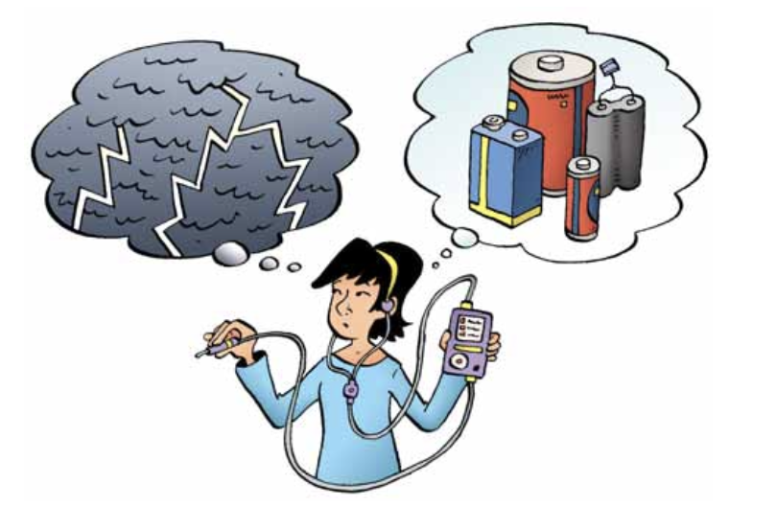
Recall the two types of electricity:

- _______________ Electricity – is a build-up of charge that ______________ in one place

- ______________ Electricity – is ________________ charges (usually through a wire)
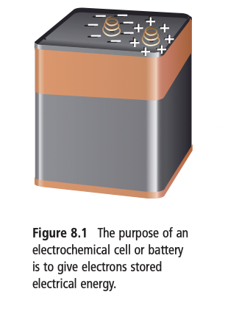
A battery is a combination of electrochemical cells _____________________________
  - Electrochemical cells convert __________________ energy into ________________ energy
- In a battery, chemical energy separates the _____and _______ charges.
- The battery ____________ are the end points where we make a connection. Extra electrons accumulate on one of the battery terminals, making it ______________ charged. The other terminal has lost these electrons and is therefore _________________ charged.
ELECTRIC POTENTIAL ENERGY
- ____________ is the ability to do work.
- _________________________ is energy a moving object has because of its motion.
- _________________________________ is the energy stored in an object.
- The electrical energy stored in a battery is called ________________________________ because the electrons have a stored energy and the ability to do work after they leave the battery.

ELECTRIC POTENTIAL DIFFERENCE
- Recall charge is measured in ______________
- The amount of electric potential energy per 1 C of charge is called the _______________ or _______________
  - Unit is the __________________, measured with a ______________________

COMPARING P.E. AND P.D.
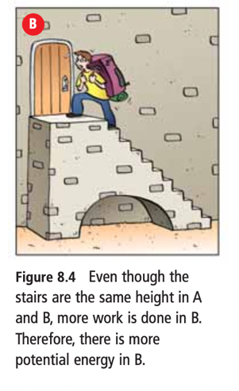 | - You can think of the _____________________________ in a battery as being like the height of the stairs.  - The ____________________________________________ in a battery is like the mass moved up the stairs.  - The potential energy in the battery is due to both the potential difference (____________) and the amount of charge that has been separated (__________________).

BATTERIES
We can classify batteries into two groups:
  - _______ cells : in devices like flashlights, toys, and watches
  - ________ cells : in cars, motorcycles, and electric wheelchairs
- Cells consist of the following parts:
  - two ________________ (2 different metals)
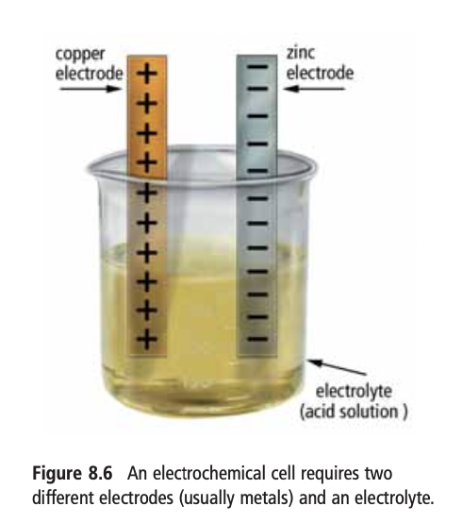
  - an __________________ (conducting substance or acid solution)

- The acidic electrolyte attacks the zinc electrode and pulls atoms off the zinc. But the zinc atoms leave __________________ behind on the electrode, and the electrode becomes _____ charged.
- At the same time, _________________________ pull ___________________ off the copper electrode. Therefore, the copper electrode has a _____ charge. Because there is an opposite charge on each electrode, there is a ______________ ___________________________ between the two electrodes.
