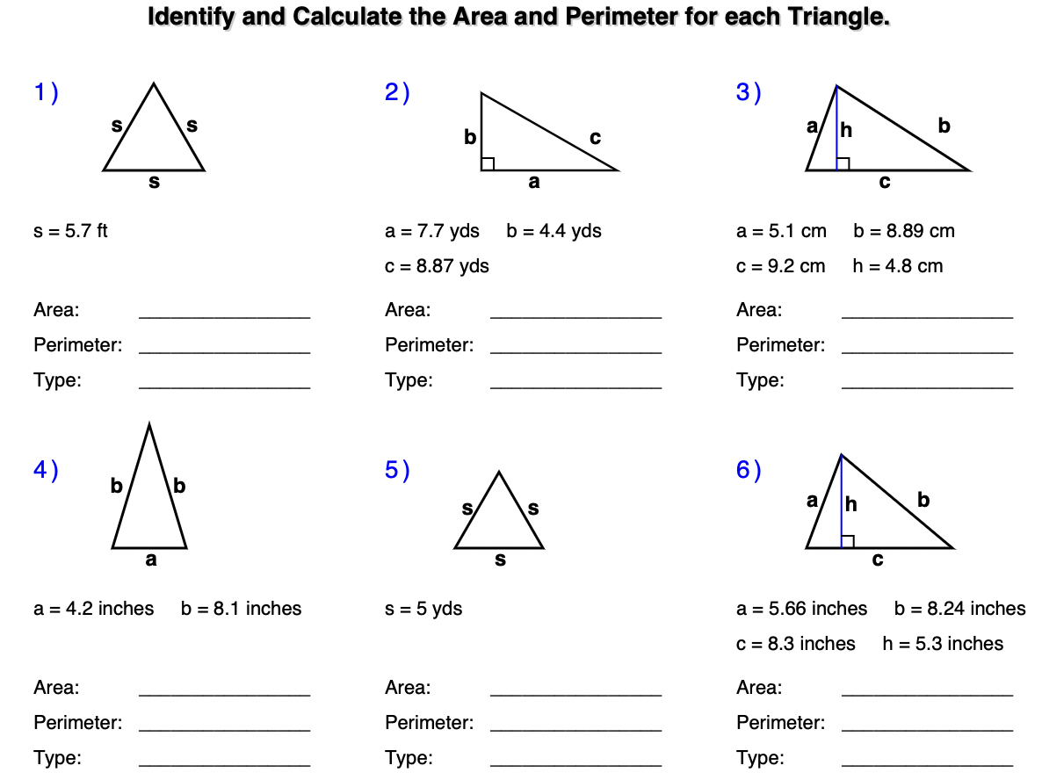

7) Two joggers run 8 miles north and then 5 miles west. What is the shortest distance, to the nearest tenth of a mile, they must travel to return to their starting point?

8) Oscar's doghouse is shaped like a tent. The slanted sides are both 5 feet long and the bottom of the house is 6 feet across. What is the height of his doghouse, in feet, at its tallest point?

9) A suitcase measures 24 inches long and the diagonal is 30 inches long. How much material is
needed to cover one side of the suitcase?

10) Find a third number so that the three numbers form a right triangle:
- 9 , 41 ii). 13, 85

