Math11W 2D Name: ________________
Measurement Review
Use you notes!

Find the area and perimeter of each of the following. Show work! Include units in answer

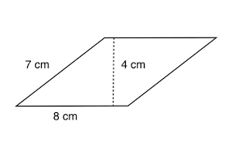  Area Perimeter | 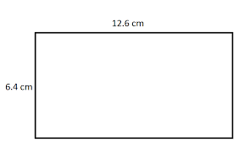  Area Perimeter
*assume units are m  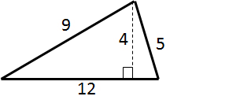  Area Perimeter | 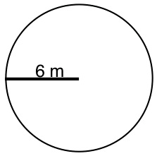  Area Perimeter
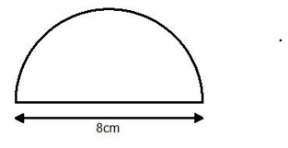  Area Perimeter | 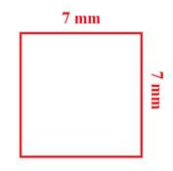  Area Perimeter
Find the missing measurement:

Given the length of a rectangle is 12 m, and it’s A is 84 m², find the width. | Given the base of an isosceles triangle is 10 mm, and it’s perimeter is 36 mm, find the length of each of the two missing sides.
Given the area of a square is 72 m², find the measurement of one of the sides. | Extension (optional): Given the area of a cirlce is 120 cm², find the radius to the nearest tenth of a cm.
Find the area and perimeter of each composite figure:
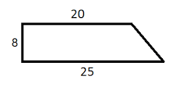
*assume unit is inches

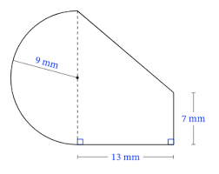

Find the area of the shaded region:
