LESSON – 2D MEASUREMENT REVIEW

GUIDED PRACTICE: 2D MEASUREMENT– CIRCLES

CIRCUMFERENCE = Distance __________________ circle. Unit = _____________

AREA = Space ____________________ circle. Unit = _____________________

Example:  circumference area  Circumference area | Example:  circumference area  circumference area

Manipulating the Formulas  What if given the circumference, and want to find d or r? | What if given the area, and want to find d or r?

PRACTICE – CIRCLES REVIEW
PART A: Find the circumference (C) and area (A) of each circle
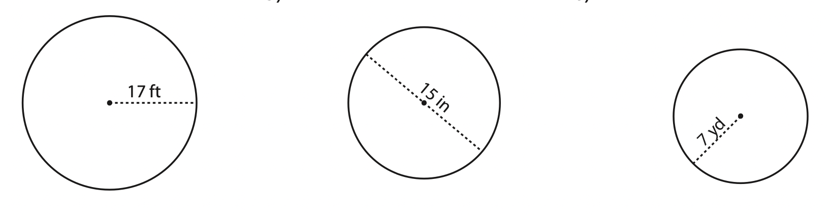
C = ___________ C = ___________ C = ___________
A = ___________ A = ___________ A = ___________
Part B: Given the circumference, find the diameter (d) and radius (r) of each circle
C = 50.3 cm
C = 6.3 cm

C = 31.4 cm

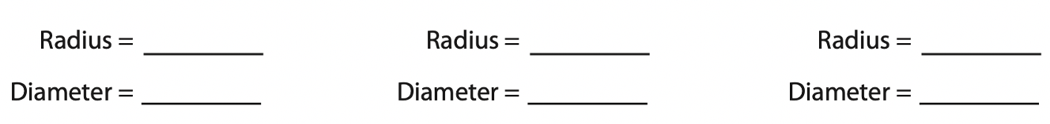
Part C: Given the area, find the diameter (d) and radius (r) of each circle
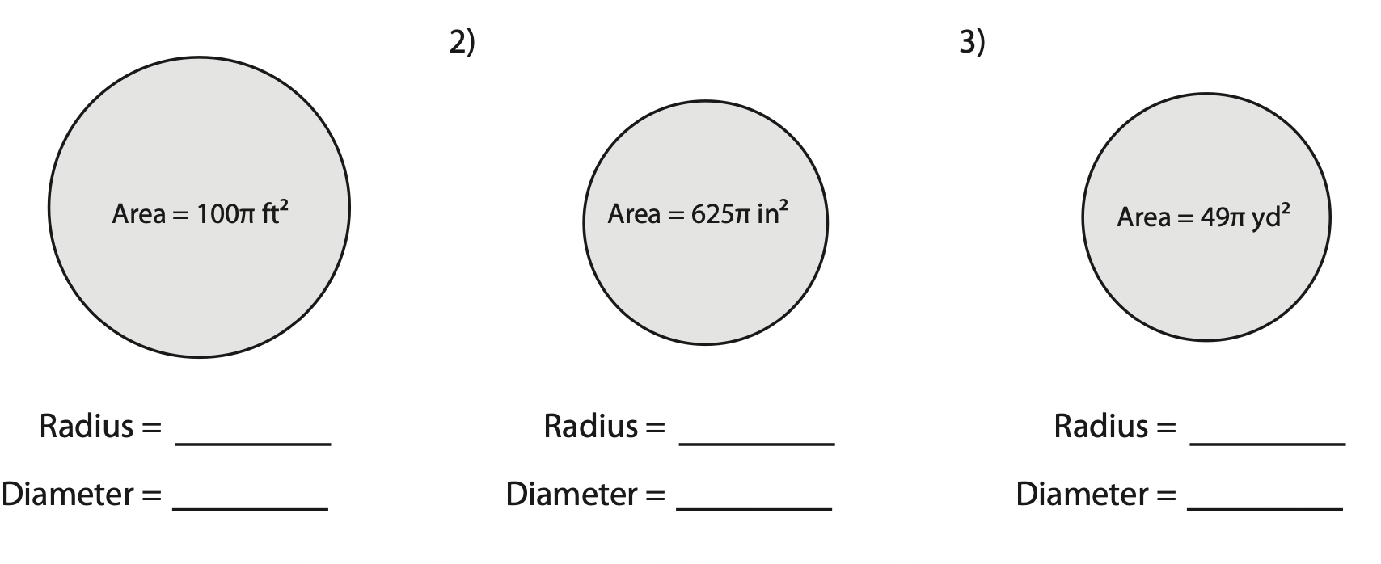
A = 3.14 cm²

A = 201.1 cm²

A = 63.6 cm²

