THE SCIENTIFIC METHOD
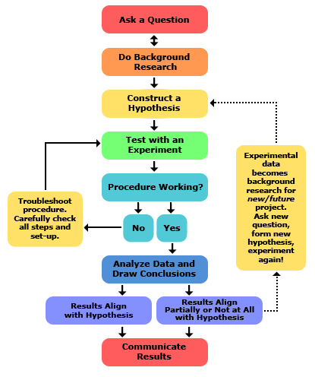
Mnemonic device to remember it:
The question needs to be _________________
- What effect does have on ?

