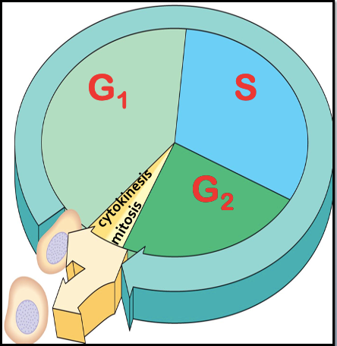
CELL CYCLE & MITOSIS
3 main phases in the cell cycle
- Interphase is normal cell function and _____________
Split into 3 parts:
- ___________________
- ___________________
- ___________________

- Mitosis is the division of the ________________.

- Cytokinesis is the division of the _________________.
End result: 2 new, _________________ cells are produced.

INTERPHASE
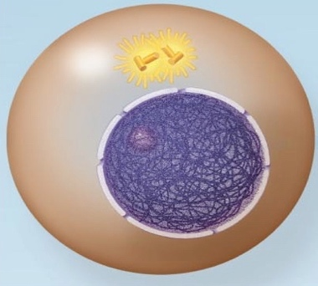  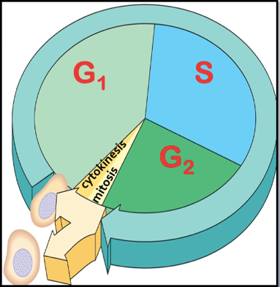  (see fig 5.5 from text re: replication) | - Nucleus is _________________________ and bounded by the nuclear membrane.  - Outside of the nucleus are two ____________________.  - Their function is to organize the __________________ into a _________________. They will begin to move apart as spindle microtubules  grow out of them.  G1 – 1st Gap  - Cell ______________________________ and makes the proteins and molecules necessary for the cell to function.  - Some ___________________ begin to duplicate.  S – synthesis  - _____________________ of DNA occurs.  - The DNA molecule ________________ with the help of an enzyme.  - ______________________ with the bases on the original DNA.  - Two new _________________ DNA molecules are produced.  - The chromosomes have _________________ and appear as a jumbled mass of fibers.  - They have ________ yet condensed.  G₂ – 2nd Gap  - Cell continues to ___________ and make materials such as proteins  - The _________________, which contains the replicated DNA, is in its loosely coiled form  - Remaining organelles (such as mitochondria and chloroplasts) are
_________________________ Now the cell is ready to divide!

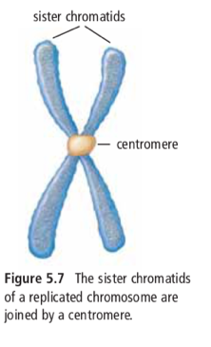
MITOSIS
The ___________- stage of the cell cycle where the nuclear contents ________________, and ________ daughter nuclei are formed.
As the nucleus prepares to divide, replicated DNA in interphase joins to form _____________________________, joined by a centromere.

PMAT

EARLY PROPHASE
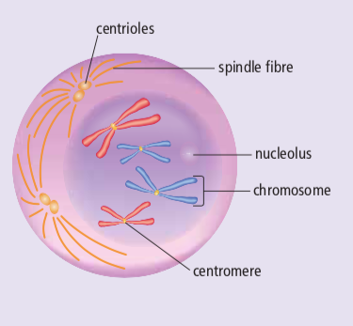 | - The chromosomes coil and thicken and become ____________ from one another. The chromosomes are now visible.  - The nucleolus _________________  - The chromosomes are doubled throughout their length.  - The centrioles separate and start moving to __________________ ends of the cell. A ________________ made of microtubules begins to form.

LATE PROPHASE
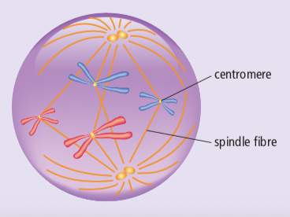 | - The nuclear membrane ________________  - The __________________ move to the opposite poles, completing _________________ (microtubules form spindle)  - The chromosomes attach to the spindle fibres at their _____________

METAPHASE
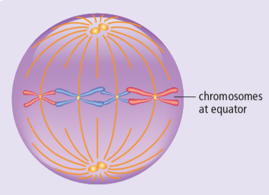 | - Each chromosome is connected to a spindle fiber at its _______________  - The _________________ are now at opposite sides of the cell.  - The _______________ fibers will push and pull the chromosomes.  - The chromosomes ___________________ at the center of the cell.

ANAPHASE
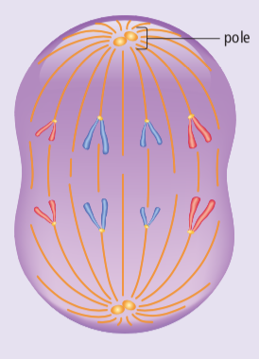 | - The microtubules begin to _________________ and this pulls the __________________ apart to opposite sides of the cell  - Once they separate, each sister chromatid is considered to be a ___________________.  - By the end of anaphase, the two ends of the cell have ____________________ and ____________________ sets of chromosomes.

TELOPHASE
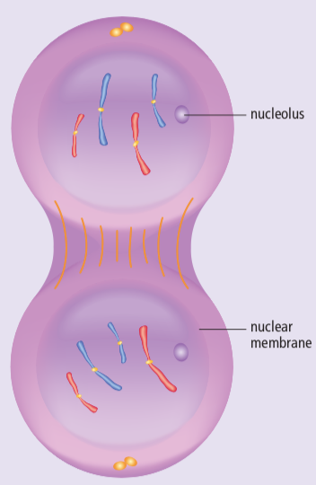 | - One _________________ set of chromosomes is now at each pole of the cell  - Spindle fibres begin to ________________  - ________________________________ forms around each set of chromosomes  - A ___________________ appears within each nucleus  - Now there are _________ nuclei in one cell, and the cell is ready to ______________________

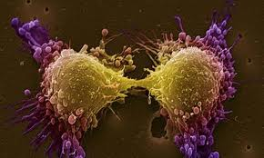
CYTOKINESIS
- The final stage in the cell cycle, and happens in conjunction with ______________________
- The _______ nuclei are __________________ into _______ daughter cells
- These new cells are _____________________ to the original parent cell

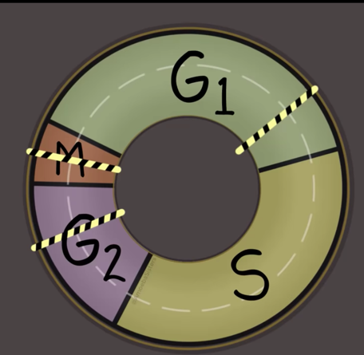
CELL CYCLE CHECKPOINTS
Checkpoints in the cell cycle will prevent division if:
  - If the cell is short of ________________________
  - If the DNA within the nucleus has not been _________________
  - If the DNA is ________________________
Mutations in genes involving checkpoints can result in an
out-of-control cell cycle.
The result can be uncontrolled cell division: ________________.
CANCER
- Cancer is a loss of a cell’s ability to control its own rate of _______________.
- Typically results from a mutation in the genetic control mechanism.
- In its simplest sense, cancer is rapid and uncontrolled cell growth.
Characteristics of Cancer Cells:
1. They lack ______________________
2. Have abnormal shaped _______________
3. Form _________________
4. Lack ______________________________________
5. Don’t ________________ to each other
6. Can ___________________
7. Can stimulate _________________________
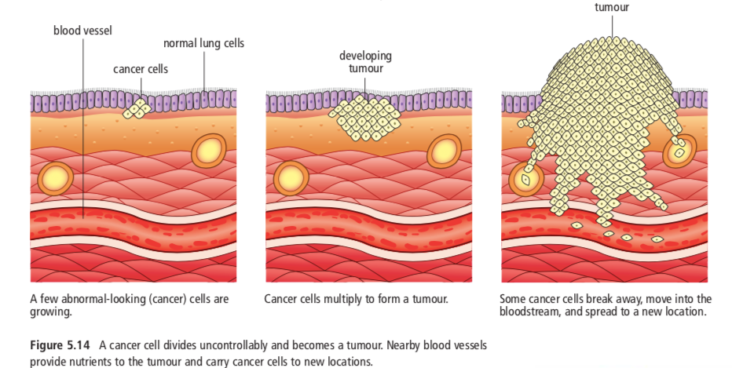

Problematic because….
- These cells are reproducing so rapidly (up to once every 3 hours) that they do not have a chance to differentiate and become __________________.
- Despite being useless, they still must be _________ and provided with the metabolites of life. They survive at the expense of _____________ cells that do have a function.
- This ultimately can lead to the death of the individual as so many normal cells become ____________________ to satisfy the voracious appetite of the cancer cells.

