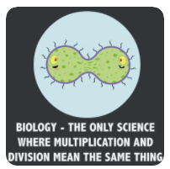
STOP MOTION ANIMATION ASSESSMENT
Curricular big idea:
- cells are derived from cells
Curricular competencies targeted:
- Formulate physical models to describe a phenomenon
- Communicate scientific ideas, claims, information for a specific purpose and audience, using appropriate scientific language, conventions, and representation
 | Emerging | Developing | Proficient | Extending
INTERPHASE
G1 phase:
- growth of cell
- some organelles doubled
S phase:
- DNA replicates
G2 phase:
- continued cell growth
- remaining organelles doubled
PROPHASE
- chromosomes distinct
- nucleolus disappears
- centrioles separate and start moving
- microtubules begin to form
- nuclear membrane disappears
- chromosomes attach to the spindle fibres at their centromeres
METAPHASE
- chromosomes connected to spindle fibers at centromere
- centrioles at opposite poles
- chromosomes line up at center of cell.
ANAPHASE
- chromatids pulled to opposite poles
TELOPHASE
- One complete set of chromosomes at each pole
- Spindle fibres begin to disappear
- Nuclear membranes forms
- nucleoli appear
CYTOKINESIS
- The two nuclei are separated into two identical daughter cells
Competency Connection:
- The big idea that “cells are derived from cells” was clearly communicated

