Resistance and Ohm’s Law
Resistance is the property of any material that ___________ __________, or hinders, the flow of electrons
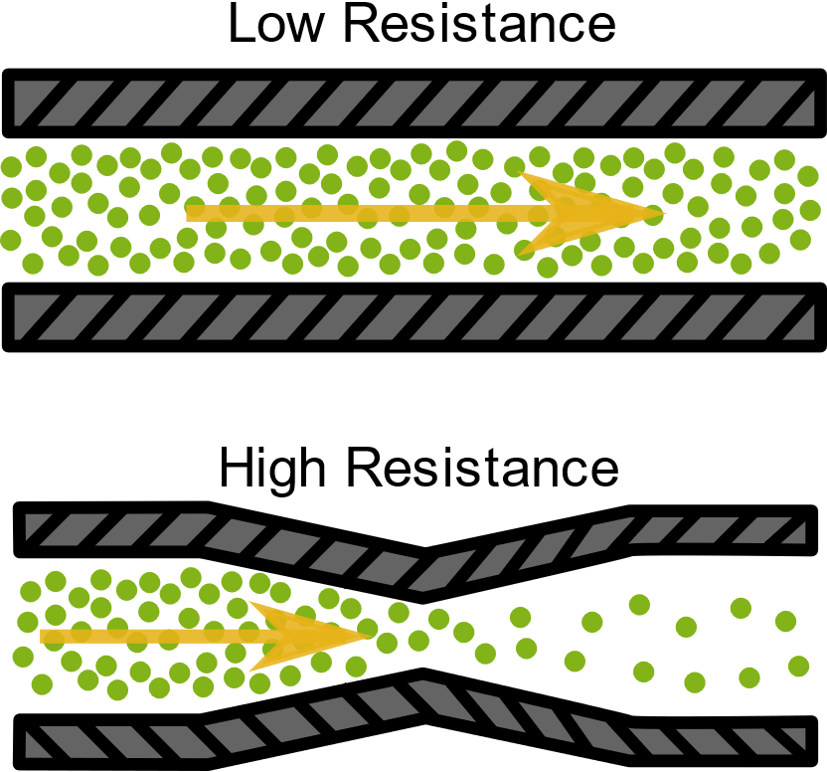
- A load, which converts _______________ ___________ into other forms of energy, works as a resistor. While passing through the load, electrons in the current will _______________ with atoms that make up the load, or even with each other; these collisions interfere with current and slow it down.
- For example, a conducting wire has _____ ________________, whereas the filament of a lightbulb has _________ _______________!
- A resistor is an electrical component that has a specific resistance, designed to _________ _____________. High voltage power lines that travel long distances often have very high current which must be _____________ prior entering households.
  - Resistors _______________ electrical energy into other forms, such as _________.
  - The circuit symbol for a resistor is:

- The symbol for Resistance is “R”, and it is measured in “Ohms” (Ω)
- An ________________ measures resistance in a circuit (it may be connected in parallel OR in series).
- Resistors are marked with _____________ bands indicating their ______________ value, and there is a legend for which numbers these colours represent!

Ohm’s Law:
- German physicist Georg Ohm discovered a _______________ between resistance, current and voltage (aka electrical potential difference) in a conductor.
- For example, he found that when he increased the ______________ in a conductor, the ______________ also increased proportionally (for given resistance).

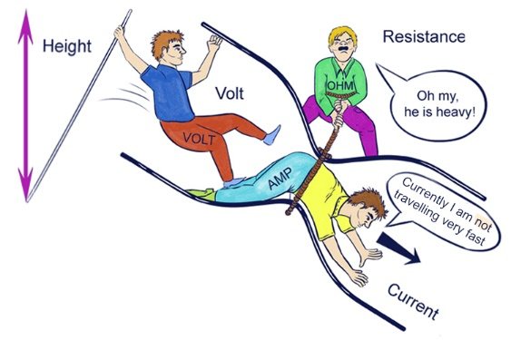
- This relationship is defined as “OHM’S LAW”:

___ stands for voltage (measured in volts, V)
___stands for current (measured in amperes or amps, A)
___ stands for resistance (measured in ohms, Ω)

- By rearranging the variables in Ohm’s Law, we can use the equation to calculate any unknown value (if given the other two values)!
By dividing both sides of the equation by R, we get an equation for calculating current I: | By dividing both sides of the equation by I, we get an equation for calculating resistance R:
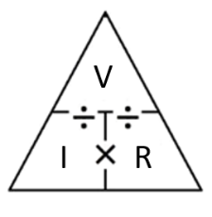
Example 1:
The current through a load in a circuit is 1.5 A. If the potential difference across the load is 12 V, what is the resistance of the load?

Example 2:
The resistance of a car headlight is 15 Ω. If there is a current of 0.80 A through the headlight, what is the voltage across the headlight?

Ohm’s Law & Metric Conversions
Ohm’s Law V = IR
Units used in the equation must be:

**If we encounter a problem with _____________ ________ than the base units, we must ____________ the units to the base unit before using the Ohms’ Law equation!

Example 3:
A 15 mA current flows through a 400 Ω lamp. What is the voltage across the lamp?

Example 4:
A 12 kΩ load is connected to a 90 V power supply. What is the current through the load in milliamperes (mA)?

Ohm’s Law & Scientific Notation
**You will encounter scientific notation either in the questions, or you will be asked to write your answers in scientific notation!
Convert the following into scientific notation:
- 12 000 Ω =
- 0.00005 mA =
- 2300 V =

