Series Vs Parallel Circuits
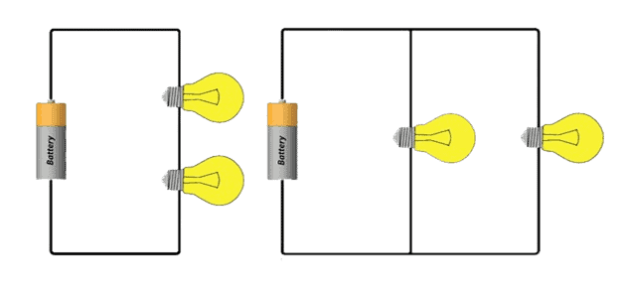
There are two ways to connect components in a circuit:
Series: | Parallel:
When one bulb goes out, they all go out, because there is only ________ pathway for the current to flow! | When one bulb goes out, the other bulbs stay lit, because there is _________ _______ one pathway for the current to flow!

Series Circuits – One Pathway:
- All components are connected one after another (______________ _____ _____________)
- Electrons must pass through ________ load in the circuit on their way back to the source
- Only ONE path for electrons to flow (no branches)
- Brightness of each bulb ___________________

Voltage:  The _______of the voltages lost on the loads equals the total voltage supplied by the battery  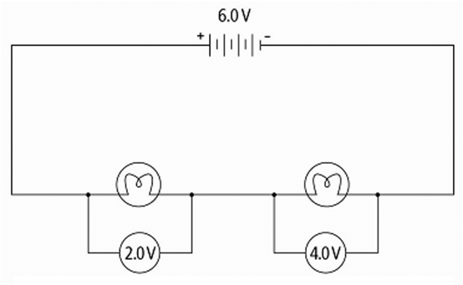 | Current:  Current measured anywhere in the  series circuit will be the ________  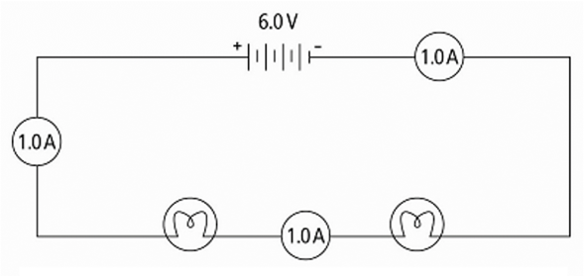
Resistance:
- The total resistance of the circuit is ______________ when resistors are placed in series (add together)
- The total current leaving the battery (and throughout the circuit) therefore _____________!
Parallel Circuits – Multiple Pathways
- Components are arranged in _______________ _____________ throughout the circuit = separate paths the electrons can take to get back to source
- At each ___________ __________(aka junction point) the current __________, then rejoins again at the source
- If there is a break in one branch, the components on other branches still work!
- Brightness of each bulb is overall ____________ than in series

Voltage:  Voltage remains the ____________ throughout each pathway of the parallel circuit  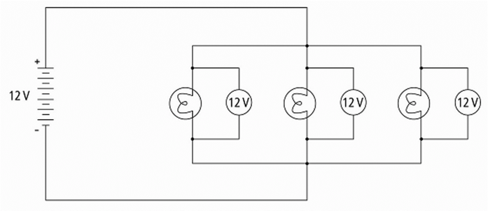 | Current:  Current splits up between the different current pathways (_________ ______________)  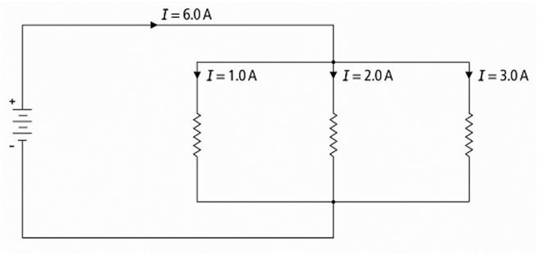
Resistance:
- The total resistance of the circuit is ______________ when resistors are placed in parallel
- The total current leaving the battery (and throughout the circuit) therefore _______________!

Remember:
SASS: PVSS:
Notes and example problems from video:

