ATOMS

A pure substance is a substance that is made up of only ________ kind of matter. Gold, water, and oxygen are all pure substances. There are two kinds of pure substances:
  - An ______________ is a pure substance that cannot be broken down or separated into simpler substances.

    - Examples: ______________ and ______________

    - An _____________ is the smallest particle of an element that retains the properties of the element

  - A _________________ is a pure substance composed of at least two elements combined in a specific way.

    - Example: ______________ is a compound that is made up of the elements hydrogen and oxygen.

Atoms are made up of smaller, ___________________ particles
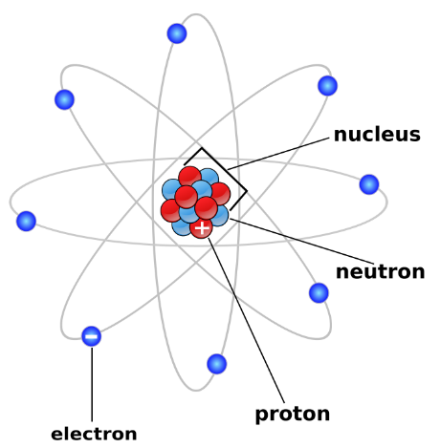
__________________

__________________

__________________

_____________ _____________ _____________

_____________

Electric Charge
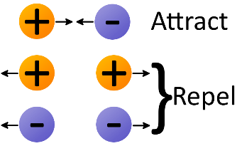
_________
The charge on the proton (+) and electron (-) are exactly

the same _____________ but _________________, so
_________
they are attracted to each other
          - This is what holds the atom together

The Nucleus
- Tiny region at the ____________ of the atom
  - It would take 10 000 nuclei lined up side-by-side to stretch across the diameter of a typical atom!
  - MOST OF THE atom is ____________________

- Contains _______________ and _________________
  - Protons & neutrons cannot leave nucleus (held together by ___________________)

  - _________________ is the only atom that has _____ neutrons in its nucleus. A hydrogen atom has one proton and one electron orbiting it
Protons
- ______________ charged particles in the nucleus of the atom.

- The number of protons in an atom’s nucleus is the ____________________ of the element on the periodic table.
Neutrons
- ________________ charged particles (____ charge) in the nucleus of an atom
- Has about the same mass as a proton
- For the atoms of the first 20 elements, the # of neutrons is either equal to or slightly greater than the # of protons.

So the NUCLEUS Has an overall (_____) charge because of the protons

Electrons
- ___________ charged particles that occupy special regions called ________________, or shells, which surround the nucleus
  - The energy levels containing electrons account for _____________ of the volume of an atom!
- The # of electrons = the # of ______________
- The electrons that occupy the outermost shell (those farthest from the nucleus) have the strongest influence on the properties of an atom.

  - These are called __________________ electrons

- Electrons orbit the nucleus very _____________, creating a spread-out negative charge, kind of like a _____________
- This is the current model of understanding an atom, called the __________ __________________________ or quantum model
- We use older models like the Bohr model (stay tuned) still to understand the probable locations and spacing of electrons, but it is important to understand the cloud model is the most accepted/up-to-date.

