MEIOSIS
- Sexual reproduction, through the ____________ of DNA, produces genetic _________________
- This variation offspring produces individuals that may have ________________ over one another.
- Sexual reproduction requires ___________ parents.
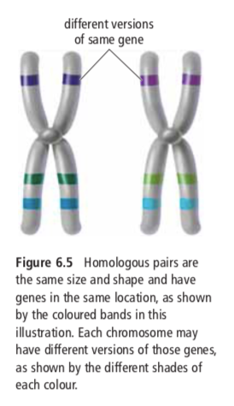
- Each parent passes on __________ its genes to its offspring.
- Must have male and female: male to produce ________ and female to produce ________
- If an organism is the result of sexual reproduction, it will have ____ sets of chromosomes.
  - One set comes from the mother and one set comes from the father.
  - These two sets are called ___________________ chromosomes.
- Homologous chromosomes carry the same genes, but they may have different ___________________ of that gene.

- Normal body cells have a _______________ chromosome number
- Diploid means there are _________ of each kind of chromosome in each cell
- They occur in ___________
- “n” is the number of ______________ chromosomes an organism has, so diploid is represented as ______
- Humans are 2n (aka diploid) because we have 2 of each kind of chromosome.
- Sex determining chromosomes in humans are the 23rd pair:
  - XX = biologically born _________________ (X from mother, X from father)
  - XY = biologically born ________________ (X from mother, Y from father)
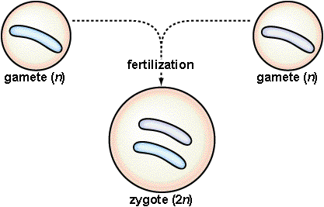
- In humans, the male and female each contribute _______ chromosomes.
- When fertilization takes place:
- egg (23) + sperm (23) zygote (46)
- The zygote goes on to develop into an embryo, and on into a complete individual. When the time comes, the cycle repeats.

Gametes are said to be ____________ (or n) because they contain only ______ of each kind of chromosome.

Big idea: The cells which produce eggs and the cells which produce sperm are diploid (or 2n)…
So how do the egg and sperm cells get to be haploid (or n)? ___________________
Meiosis is a process of ________________________________ in which the number of chromosomes per cell is cut in ______________ through the __________________________ of homologous chromosomes.
- Occurs in the _________ cells only: the egg and sperm.
- Purpose is to _______________ the chromosome number of the egg and sperm by ____________.
- Like mitosis, meiosis is preceded by the __________________ of chromosomes.
- Unlike mitosis, this replication is then followed by __________________________: meiosis I and meiosis II.
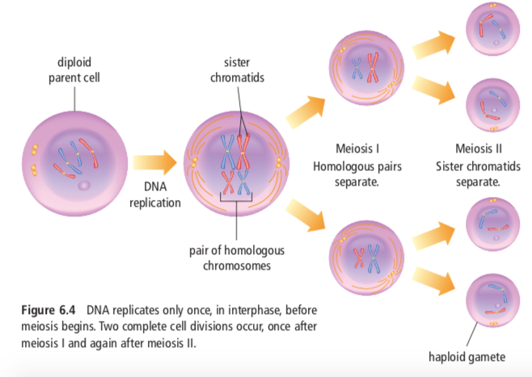
Interphase | The _______________________ replicate. It is similar to chromosome replication of mitosis. Two identical sister ___________________ are held together by a centromere.
MEIOSIS I  Prophase I | Chromosomes shorten and thicken. Each chromosome pairs with its corresponding __________________ chromosome to form a ______________.  - During Prophase I, each pair of chromatids lines up next to its homologue  - This pairing of homologous chromosomes produces tetrads.  - A tetrad consists of ______ chromatids  - Crossing over is the exchange of genetic information (___________) between segments of homologous chromosomes during meiosis.
Metaphase I | _________________ line up at the center of the cell.
Anaphase I | The tetrads break apart and the pairs move to ____________________ sides of the cell. Sister chromatids remain attached at their centromeres.
Telophase I | The cell separates into _________ cells  Meiosis I results in ______ haploid (1n) daughter cells, each with ________ the number of chromosomes as the original cell.

 | MEIOSIS II  Prophase II | The pairs of ____________ ____________________ start toward the center.
 | Metaphase II | Pairs of sister chromatids line up at the ________________
 | Anaphase II | The pairs of sister chromatids separate and move to ____________________ sides of the cell.
Telophase II |  | Results in ______ new cells that are ____________ (1n) and all ____________ from each other.
The Importance of Meiosis
1 (2n) cell ------->
The offspring will receive a ____________ combination of genetic information.
This leads to variation (called ___________________ ___________________) in the offspring.

Mitosis vs Meiosis

