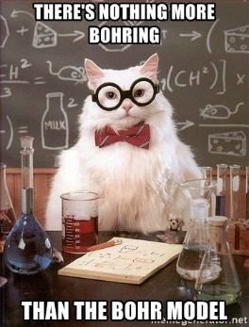
Science 9 Notes Name: ______________________ Blk: ____
CHEMISTRY UNIT – BOHR MODEL DIAGRAMS
(AKA Energy Level Model)
- Electrons surround the ________________________ of an atom in three dimensions, making atoms ____________________
- Think of electrons as being in the different energy levels like concentric spheres around the nucleus.
- Since it is very difficult to show these spheres, the energy levels are typically shown in _______ dimensions, which we now know is not the most accurate/current version of the atomic model (quantum mechanical model) | 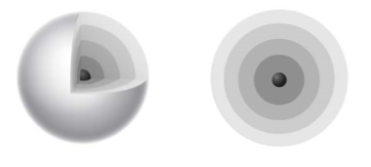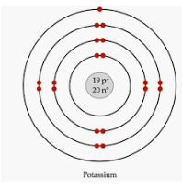
PARTS OF AN ATOM – RECAP
- Proton - Positively charged particle in the ___________________ of the atom. The # of protons in an atom’s nucleus is the atomic number.
- Electron - Negatively charged particle ___________________ the nucleus of the atom. The # of electrons surrounding the nucleus of an atom is equal to the # of __________________________ in the atom’s nucleus.
- Neutron - Particle in the __________________ that has about the same mass as a proton but has no charge. For the atoms of the first 20 elements, the number of neutrons is either ______________ or slightly _________________ than the # of protons.
WHAT ATOM IS THIS?
 | 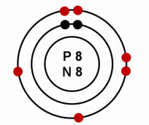 |  |  | - The nucleus is represented by a dot in the center which contains both protons and neutrons. Some models show it as a dot, other models show P = # and N = #  - The smaller dots surrounding the nucleus represent electrons in the energy levels.
 |  | - How many electrons:  - Which means there are how many protons: |  |  |  | - And the # of protons represents the:  - Which element has this atomic number:
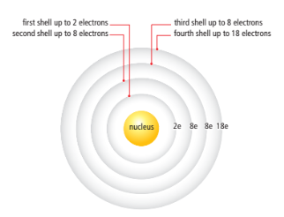 |  |  |  |  | - Electrons exist in ________________ pattern, filling from inside shell to the outside  - The electrons in the outermost shell (those farthest from the nucleus) have the __________________ influence on the properties of an atom.  - These electrons in the outermost shell are called _______________________________  - The shell that contains the outermost electrons is called the ______________________________
USE YOUR BOHR TABLE TO PRACTICE A FEW
EXAMPLE #1 – Neon
- Atomic # = # protons:
- Neutrons = atomic mass – protons

- Electrons = # protons:
- Electrons arranged 2-8-8-18 pattern

EXAMPLE #2– Phosphorus
- Atomic # = # protons:
- Neutrons = atomic mass – protons

- Electrons = # protons:
- Electrons arranged 2-8-8-18 pattern

Try one on your own - Calcium

