LESSON - CONSTRUCTING GRAPHS
Resource: See Types of Graphs Reference Sheet handout
GUIDED PRACTICE: CONSTRUCTING GRAPHS
Question #1: How many Skittles are there of each colour?
- Decide: What type of graph makes the most sense to use and why?

- __________________ because ____________________________________

- Let’s create a data table that works to collect our data.

- Now let’s create the graph to represent the data

- Analyze: What does this graph tell us at a glance?

Question #2: What colour of Skittle does our class enjoy?
- Decide: What type of graph makes the most sense to use and why?

- __________________ because ____________________________________

- Let’s create a data table that works to collect our data.

- Now let’s create the graph to represent the data

- Analyze: What does this graph tell us at a glance?
Question #3: What effect does consuming Skittles have on blood sugar levels??
- Decide: What type of graph makes the most sense to use and why?

- __________________ because ____________________________________

- Let’s look at a (totally made up) data table:
Number of Skittles | Blood Sugar Level (mg/dl)
5 | 100
10 | 120
18 | 140
31 | 200

- Now let’s create the graph to represent the data

- Analyze: What does this graph tell us at a glance?

- Estimate the blood sugar level after 25 skittles: ________ 0 skittles? _______

  - This skill is called :

Question #4: What trend do we see of Skittles given out to Trick-or-Treaters at Halloween over a 5-year period in Willoughby?
- Decide: What type of graph makes the most sense to use and why?

- __________________ because ____________________________________

- Let’s look at a data table:
Year | 2014 | 2015 | 2016 | 2017 | 2018
# Skittles distributed | 8,000 | 8,200 | 8,400 | 9,200 | 9,500

- Now let’s create the graph to represent the data

- Analyze: What does this graph tell us at a glance?

SCATTER PLOT – TRENDLINES & CORRELATION

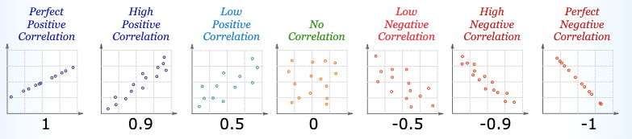
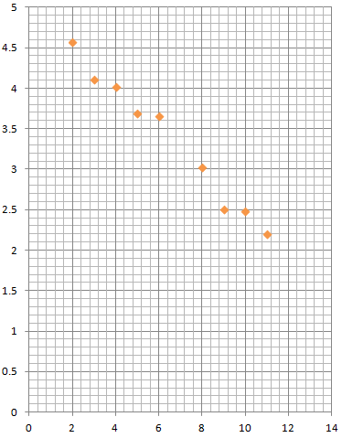
Instructions: Draw the trendline on each of the following graphs and indicate the correlation
