Science 9 – Chemistry Unit Name: __________________

THE PERIODIC TABLE OF ELEMENTS

- An organized chart containing information about the atoms that make up all matter
- An ________________ is a substance made up of only ________ type of atom.
- There are currently _______ identified elements
- The table is organized based on their ___________________
- The chemical symbol for each element consists of 1 or 2 letters (or the newer ones have 3)– the symbol is ______________________
- If the symbol is only 1 letter, that letter is ___________________
- If it is 2 or 3 letters the _____________ letter is capitalized, and the 2nd (& 3rd) letter is ________ capitalized.
- Originated in 1867 by Russian chemist & teacher, __________________

TABLE ORGANIZATION
- Going horizontal (side-to-side) called: ____________________
- Going vertical (up-and-down) called: ______________________

METALS & NON-METALS
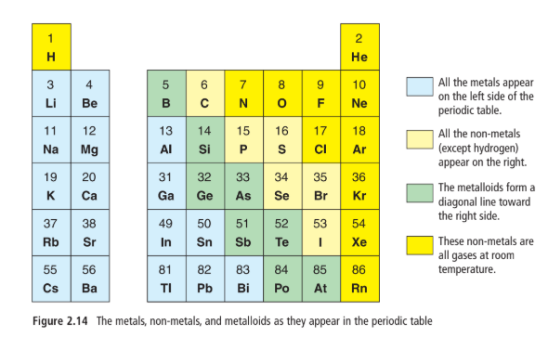

 | State at Room Temp | Appearance | Conductivity | Malleability and ductility
Metals
Non-metals
Metalloids
(semi-metals)

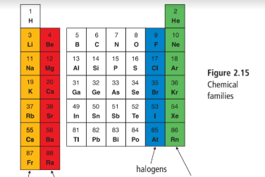
CHEMICAL FAMILIES

FAMILY:
GROUP:
 | - Highly reactive  - Reactivity increases as you go down the table  - React with both oxygen and water  - Low melting points (all below 200˚C)  - Soft and can be cut with knife | - less reactive than alkali but will burn in air if heated  - Produce bright flames and are used in fireworks  - React with water but less vigorously than alkali  - Low melting points (all below 200˚C)  - Soft and can be cut with knife | - Non-metals  - Highly reactive  - States at room temp:  F and Cl = gases  B = liquid  I = solid  - Astatine is v. rare (no one has collected enough to determine its physical properties) | - Most stable  - unreactive  - at room temp:  - colourless  - odorless  - gases  - Some glow (use electricity to ‘excite’ the atom)

READING SYMBOLS:

Atomic Number: the number of ____________________ in the nucleus of each atom. It is always a whole number.
- Pattern: atomic numbers ______________________ one by one through the periodic table
Atomic Mass: the mass of an average atom of an element. It is written as a decimal.
- Pattern: atomic mass tends to increase along with atomic number
- Mass is a combo of the ___________________ & ___________________ in an atom.
- *There are some exceptions, i.e. Co and Ni
Ionic Charge: electric charge that forms on an atom when it gains/loses ________
- An electrically charged atom is called an _______________.
- An atom that has gained electrons is ___________________, and one that has lost electrons is ___________________
- Some elements have a multiple ion charge – these elements can form ions in more than one way.
- Pattern:
  - Elements on the LEFT side of the table generally form ____________
  - Elements on the RIGHT side (except for the last column) generally form _______________ ions.
  - Elements that are in the ______________ column often form ions with the same _____________ charge as other elements in that column

