Science 9 Notes Name: ______________________ Blk: ____
CHEMISTRY UNIT – IONS
Valence Electron Patterns
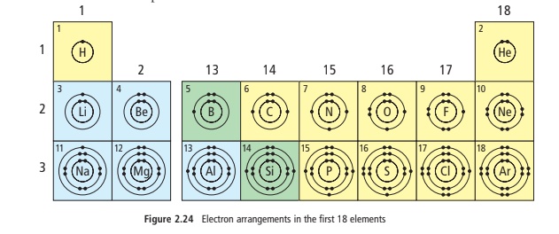
Most elements in the same family have the same number of _________________________

Example: halogens have ______ valence electrons

Elements in the same period (row) have valence electrons in the ___________________

The period number indicated that number of shells that have ___________________

Noble Gas Stability
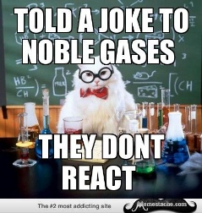
The noble gases (He, Ne, ar, Kr, Xe, Rn) are normally ___________________,which means the atoms do not form new substances with other atoms.

- Why? Because their atoms have ___________________ valence shells – the max number of electrons in their outer shells. That makes them stable.
- For two atoms to join together to make a new substance, atoms must

_________________ ___________________ electrons. But atoms with filled valence shells will not easily trade or share electrons. They have what is called noble gas stability.

Gaining/Losing Electrons
Atoms from other families often try to achieve a kind of ___________________ similar to the noble gases. To do this they will gain or lose electrons.

Metals:
- Have ___________________ valence electrons ; They will often ___________________ them all
- When metals lose their valence electrons, their remaining electrons will have the same

arrangement as the ___________________ noble gas.

Non-metals:
- They _______________ 1, 2 or 3 extra electrons in order to achieve noble gas stability
- They gain exactly enough to achieve the same electron arrangement as the noble gas in

___________________________
What Are Ions
Recall that an ion is an electrically charged atom. The ion charge is an electric charge that forms on an atom when it gains or loses electrons.

- An atom that has gained electrons is a ___________________ ion because the extra electrons make it negative.
- An atom that has lost electrons is a ___________________ ion because the loss of electrons removes negative charge

Some elements have a multiple ion charge, meaning they form ions in multiple ways.

What pattern do you notice on the table?

- Elements on ___________________ tend to form positive ions

- Elements on ___________________ tend to form negative ions

- Elements in same column form ions with same charge as other elements in that column

How Atoms Become Ions
Now that we get that an atom that has gained or lost electrons is called an ion and Ions carry an electrical charge…
- An atom of any metal can ______________ electrons and form ________________ ions

- An atom of any non-metal (except a noble gas) can ___________________ electrons

- and form ___________________ ions

- Ions have the same electron arrangement as the ___________________

- The charge on an ion is equal to the ___________________ of the charges on its protons and electrons

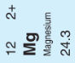
Example: Magnesium

The ion Mg²⁺ has:
______ Protons ________

______ Electrons ________

For a total charge of: _________

