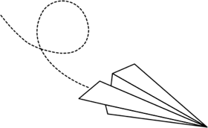
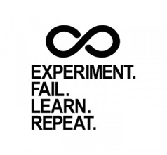
Airplane Lab Learnings
“Your best teacher is your last mistake” -unknown
The QUESTION
- Needs to be __________________ & __________________

- Ex: What effect does _____________ have on ________________?

The MATERIALS
- What do you need to do better?

The DATA COLLECTION
- What do you need to do better?

- How would you explain precision vs accuracy?

The GRAPH
- When is a BAR graph used vs a SCATTER graph?

quaLitative
quaNtitative

The CONCLUDING STATEMENT
- What is needed?

Add any additional learnings to the back of this. Review this often, especially before next lab!

