Science 9 – Spindlove – Chem Notes Name: _____________________
ATOMS
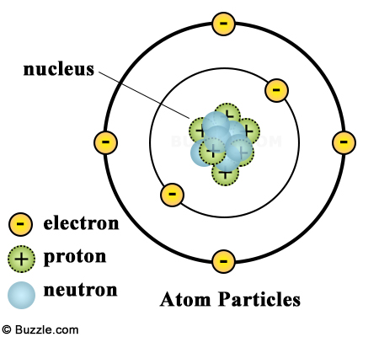 | Subatomic Particles:  - Neutrons: ____ nucleus; ______ charge  - Protons: ______ nucleus; _____ charge  - Electrons: _____________ nucleus; ___ charge  *spread-out charge. We say electrons exist in _____________________ (sometimes called shells or orbitals)  NOTE: We recognize this is not the current, _____________ model.
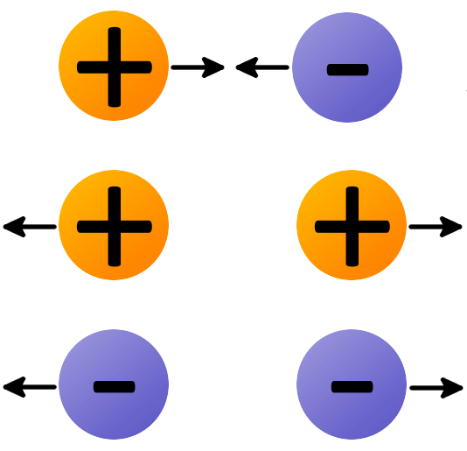 | - Charges that are opposite ______________ each other  - Charges that are alike ______________ each other  - The charge on the proton and electron are exactly the same ______________ (strength) but ______________, so they are ______________ to each other.  - This is what holds the atom together
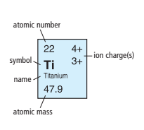 | - Atomic Number: the number of ______________ in the nucleus of each atom. It is always a whole number.  - Pattern: atomic numbers increase one by one through the periodic table  - Atomic Mass: the mass of an average atom of an element. It is written as a decimal. Mass is a combo of ______________ & ______________  - Pattern: atomic mass tends to increase along with atomic number  - *There are some exceptions, i.e. Co and Ni
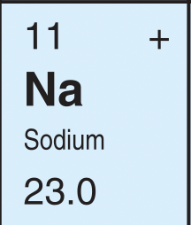
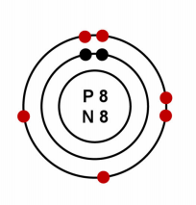 | - How many electrons: ___________  - Which means there are how many protons: ___________  - And the # of protons represents the: ______________  - Which element has this atomic number: ______________
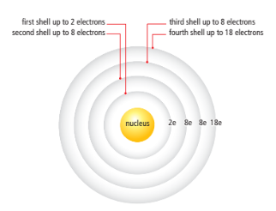
- Electrons exist in ______________ pattern, filling from ______________ ______________ shells
- The electrons in the outermost shell (those farthest from the nucleus) have the ______________ influence on the properties of an atom
  - These electrons in the outermost shell are called ___________________________
  - The shell that contains the outermost electrons is called the ____________________________.

Example: Let’s draw the Bohr model of Neon | - Atomic # = # protons _____________  - neutrons = atomic mass – protons ______________  - electrons = protons ______________  - Electrons arranged 2-8-8-18 pattern
Draw the Bohr model of Phosphorus | - Atomic # = # protons _____________  - neutrons = atomic mass – protons ______________  - electrons = protons ______________  - Electrons arranged 2-8-8-18 pattern
LEWIS STRUCTURES | Show arrangement of ______________electrons only  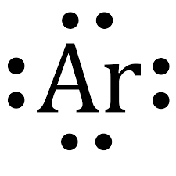
EXAMPLES: Draw Lewis Dot Diagrams of the following:
Be Mg F Cl

