Model of a Traditional Indigenous Bentwood Box
--- Planning sheet ---

- Select a design to use for one of the faces of your box (based off pdf on website and copies in class). This will help determine dimensions. Include a sketch of your dimensions below for your box and lid. You have 2sq.ft of material to use only!

- Calculate how much material will be required for this box (i.e. the surface area). Remember, you have 2sq.ft of material to use only!

Model of a Traditional Indigenous Bentwood Box
--- Planning sheet ---

- Once your dimensions are figured out and you know you have enough material, calculate how much this box can hold (i.e. the volume)

- Select a design to use. This will be redrawn as a scaled drawing somewhere on your box (on the lid or under the lid).

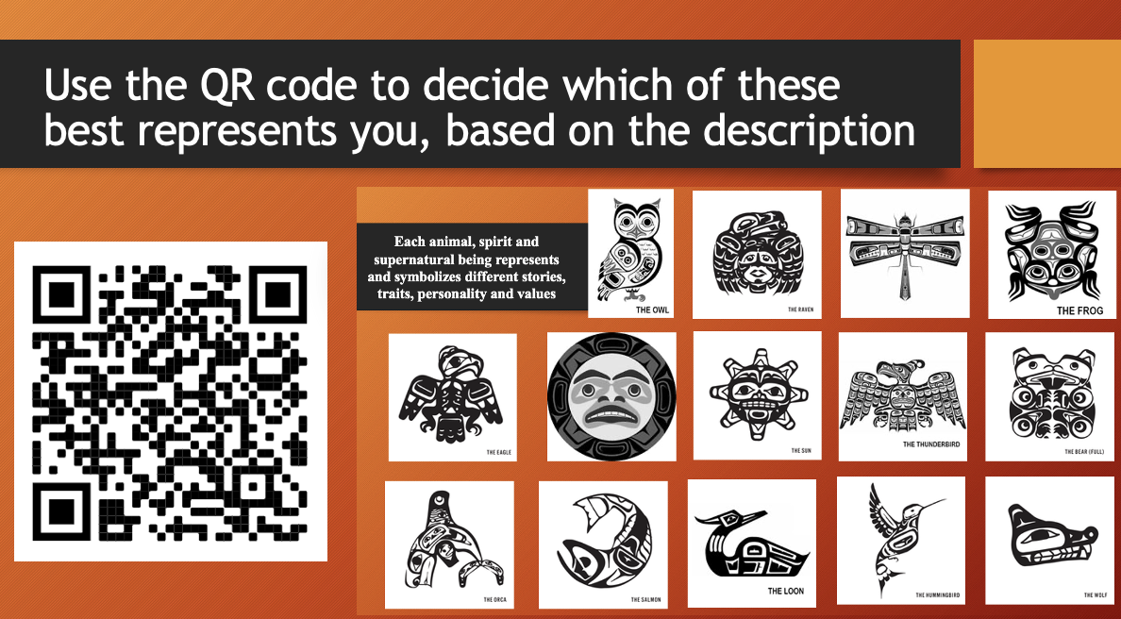
Model of a Traditional Indigenous Bentwood Box
Teacher assessment

Include a sketch of your dimensions below for your box and lid

 | Emerging | Developing | Proficient
- All measurements were included on sketch
- Units were provided
- Measurements of box matches sketch

Calculate how much material was required for this box (i.e. the surface area)

 | Emerging | Developing | Proficient
- Box calculations correct
- Lid calculations correct
- Total surface area provided, with units

Calculate how much this box can hold (i.e. the volume)

 | Emerging | Developing | Proficient
- Volume calculation correct, with units

Complete a scaled drawing

 | Emerging | Developing | Proficient
- Original drawing had precise grid
- Scale was included
- Drawing is to scale
- Drawing is a replica of original (not freehanded)

Once project is complete: self-assessment
Learning Targets | Emerging: Understanding with support required; unable to demonstrate independently | Developing:  Understand with small amounts of support; may need redirection | Proficient: Understand without support; may have small errors
I can identify the 2D shapes that make up 3D objects
I can create a 3D model based on a 2D net drawing
I can measure the dimensions of a 3D object and calculate its surface area
I can measure the dimensions of a 3D object and calculate volume
Curricular Competencies | Emerging: Understanding with support required; unable to demonstrate independently | Developing:  Understand with small amounts of support; may need redirection | Proficient: Understand without support; may have small errors
Reasoning and modelling
- Model with mathematics in situational contexts
Understanding and solving
- Visualize to explore and illustrate mathematical concepts and relationships
- Apply flexible and strategic approaches to solve problems
- Solve problems with persistence and a positive disposition
- Engage in problem-solving experiences connected with place, story, cultural practices, and perspectives relevant to local First Peoples communities, the local community, and other cultures
Communicating and representing
- Represent mathematical ideas in concrete, pictorial, and symbolic forms
Connecting and reflecting
- Use mistakes as opportunities to advance learning
- Incorporate First Peoples worldviews, perspectives, knowledge, and practices to make connections with mathematical concepts

