Name: |  | Date:

Student Exploration: Circuit Builder

Directions: Follow the instructions to go through the simulation. Respond to the questions and prompts in the orange boxes.

Vocabulary: circuit, closed circuit, conductor, current, electron, fuse, insulator, open circuit, parallel circuit, series circuit, short circuit

Prior Knowledge Questions (Do these BEFORE using the Gizmo.)

- What do a light bulb, a toaster, a radio, and a computer all have in common?

- Suppose you connect a battery to a small light bulb with a single wire. What do you think will happen? Explain your answer.

Gizmo Warm-up: Build a circuit

- Using the Standard components in the upper left of the Gizmo, try to get a light bulb to light up. You can drag as many bulbs, wires, batteries, switches and fuses as you like onto the circuit board.

A circuit is a path containing easily moveable charges. When the light bulb lights up, negatively-charged particles called electrons are flowing through the wire and bulb. This flow is called current.
✏️ Hand draw in this space or click here to select EDIT to use the drawing tool.

- Now try to light the bulb with the smallest number of components.

- Based on what you have seen, what must be true for a circuit to light a bulb?

Activity A:  Closing a circuit | Get the Gizmo ready:  - Click Clear.  - Turn on Show current and select Electron flow.  - Set up components as shown to the right. | 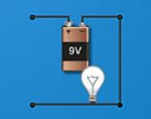

Introduction: You should have just built an open circuit (shown above). The gap on the left prevents the flow of charges. There are no gaps in a closed circuit, so charges can flow.

Question: What materials will close a circuit?
- Predict: Conductors are materials with easily movable charges, allowing current to occur. Insulators do not have easily movable charges, so current is not produced. Look at the nine Materials at lower left.

Which do you think are conductions?
Which are insulators?

- Predicted conductors:
- Predicted insulators:

- How could you use your open circuit to test if a material is a conductor or insulator?

- Experiment: Drag each material into the gap of the open circuit. If the light bulb lights, the material is a conductor. If not, the material is an insulator. Keep track of your findings below.

Conductors | Insulators

- Analyze: Look at your list of conductors.

    - What kind of material are most conductors?

    - Did any conductor have a different effect on the light bulb than the others? Explain.

Activity B:  Series circuits | Get the Gizmo ready:  - Click Clear.  - Check that Show current is on.  - Build the circuit shown to the right. | 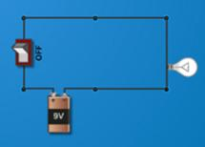

Question: In a series circuit, components are arranged in a single loop. What are the characteristics of series circuits?

- Observe: Turn the switch to ON, which allows charges to flow through the circuit. Notice how brightly the bulb is lit and how much current (shown by the arrows) there is. Now start replacing wire segments with light bulbs. You can fit up to four bulbs in this series circuit.

  - What do you notice about the brightness of the bulbs as you add more bulbs?

  - Do all the bulbs have the same brightness?

  - Look at the current arrows in each part of the circuit. Are there any parts of the circuit that have more current than other parts?

- Explore: Now remove a light bulb from your series circuit, leaving a gap. What happens to the remaining bulbs?

- Extend your thinking: Build another series circuit with several light bulbs, a 1.5-volt AA battery, and at least a few wire segments. Turn the switch to ON.

  - How does a circuit with a 1.5-volt battery compare to a circuit with a 9-volt battery?

  - Replace one of the wire segments with another 1.5-volt battery. What happens?

- Compare: Compare a series circuit powered by six 1.5-volt batteries to a series circuit powered by a single 9-volt battery. Make sure there are equal numbers of light bulbs in each circuit and that the batteries are all in the same orientation.
What do you notice?
Why is this true?

Activity C:  Parallel circuits | Get the Gizmo ready:  - Click Clear.  - Check that Show current is on.  - Build the circuit shown to the right. | 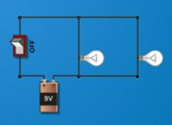

Question: In a parallel circuit, there is more than one path that current can take. What are the characteristics of parallel circuits?

- Observe: Turn the switch to ON, which allows charges to flow through the circuit. Notice how brightly each bulb is lit and how much charge is flowing in each part of the wire. Are the two bulbs equally bright?

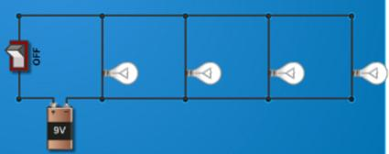

- Experiment: Add two more light bulbs to the circuit, as shown to the right. Turn the switch to ON, and observe the brightness of the bulbs.

- Did the brightness of the bulbs change?
- Remove one light bulb. What happens?

- How did the parallel circuit respond differently to these changes than a series circuit?

Adding bulbs:
Removing bulbs:

- Observe: Replace one of the light bulbs in your circuit with a wire. Now there is a path in the circuit with no light bulb to slow down the moving charges. What happens?

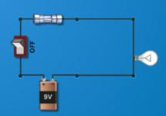
This situation is called a short circuit. The red arrows indicate enormous current. This is very dangerous because so much current will heat up the wire and could even start a fire!

- Apply: Short circuits can be avoided using fuses, devices that melt if too hot. Set up the circuit shown to the right, and turn the switch ON.

- What happens?
- Create a short circuit. What happens now?
- How does a fuse make the circuit safer?

