Assignment
Part A: CONSTRUCTING GRAPHS
Resource: See Types of Graphs Reference Sheet handout and notes.
**Make a graph of all the data given for each question below (you will need to draw two separate graphs). Remember to include all criteria discussed in class, and then answer the questions that follow on a separate paper and attach your graphs and responses to this sheet. It is recommended that you read over ALL questions before starting.

- The following data was collected by measuring the length of vines grown over a period of 30 days. Draw a graph to represent this data.
No. Days | 26 | 2 | 30 | 4 | 10 | 12 | 0 | 16 | 18 | 20 | 8 | 22 | 24 | 28
Length in light (cm) | 20.8 | 15.5 | 23.0 | 15.6 | 16.1 | 16.5 | 15.3 | 16.8 | 16.9 | 18.6 | 16.0 | 19.1 | 19.9 | 21.9
Length in dark (cm) | 19.5 | 14.9 | 20.3 | 15.2 | 16.6 | 16.9 | 14.5 | 18.0 | 18.2 | 18.6 | 16.2 | 18.9 | 19.1 | 19.7

a. What type of correlation is shown by each trend line (light, dark)? Explain how you know.
b. Clearly show the slope calculation for each line of best fit. Use the slopes to explain the relationship between the IV and DV in each case (light, dark).
c. Extrapolate to estimate the length for plants grown in light and in dark for 35 days.
d. Interpolate to estimate the length for plants grown in light and in dark for 14 days.

- The following data was collected by heating wax up to its melting point and measuring its temperature as it cooled. Draw a graph to represent this data.
Time (min:sec) | 2:38 | 26:10 | 4:49 | 6:52 | 0:45 | 8:01 | 10:26 | 20:32 | 12:32 | 14:55 | 28:57 | 16:16 | 18:23 | 22:11 | 24:09 | 30:45 | 32:39
Temperature (°C) | 65.2 | 32.8 | 58.7 | 52.3 | 72.7 | 48.1 | 45.9 | 34.9 | 41.0 | 39.8 | 31.2 | 37.1 | 36.0 | 33.02 | 32.2 | 30.6 | 29.7
a. What type of correlation is shown by the trend line? Explain how you know.
b. Is it appropriate to calculate slope of the line of best fit in this case? Explain how you know.

Part B: SCATTER PLOT TREND LINES & CORRELATIONS

** Instructions:
a) Draw the trend line (line of best fit) on each of the following graphs as appropriate (extend your line as you would for extrapolation).
b) Calculate the slope each line of best fit drawn for Graphs B and D only (on this paper).
c) Indicate the type of correlation shown by each graph (on this paper; reasoning not needed).
Graph B:
Graph A:
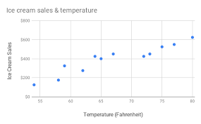
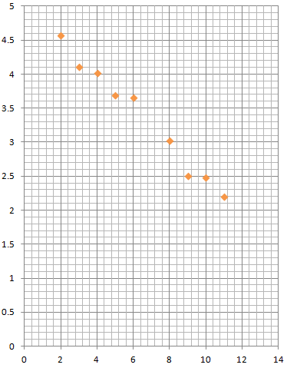

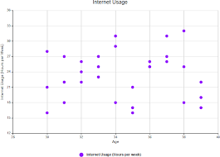
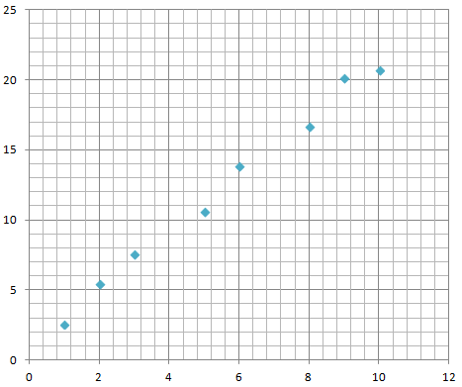
Graph D:
Graph C:

