PreIB Science – Spindlove + Kovacevic
GRAPHING

*Refer to Types of Graphs reference sheet

Bar Graphs
- Used to represent _____________________ data that is ________________________

- Does __________ represent relationship between 2 variables

- Can be used for ________________________ data (why we chose the experimental set-up we did)
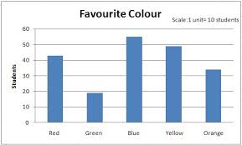
The big idea is that bar graphs are used in Science as a starting point to drive further experimentation. It’s not usually an end product for us!

Scatter Graphs
- Used to represent ____________________________ data (i.e. NOT categorical)

- Represents _______________________ between 2 variables

  - What effect does ______ have on ______?

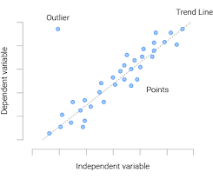

Graphing Guidelines:
- Need a ________________. “Comparison of….” or “Relationship between…” are good ways to start. Mention both quantities (__________________) you are comparing.

- Label the ______________with the quantity involved for each variable.

- Look at _____________________ (for each variable) and determine ____________ for the x- and y- axis. Graph should fill ___________________) of the page.

Scale must increase by regular _________________ for the entire axis.

Your scale need not start at zero if it is not ________________ for your data.

- Plot points in pencil. Draw dot for each point and then ___________ (like bullseye). If plotting >1 set of data on one graph, use different ___________________________.

- Draw a smooth line through all the points, called a “_________________________”. (Should be as close to each point as possible, but can disregard extreme outliers.)

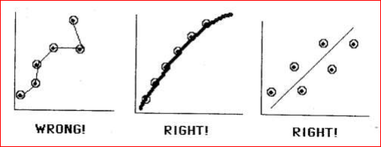

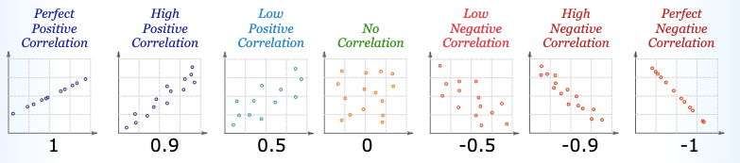

- Calculate the RATE of ________________________ in your line of best fit (aka SLOPE !)

Choose two easily read _____________________ on your graph (x₁, y₁) and (x₂, y₂), which are NOT part of your data set.

Rate/Slope = $\frac{change in dependent \left(y\right)variable}{change in independent \left(x\right)variable }$ = $\frac{y_{2}-y_{1}}{x_{2}-x_{1}}$ = answer (+ units)

Ex:

We can use the line of best fit to estimate by _________________________ (estimating within

data set), or ________________________ (estimating outside of data set)
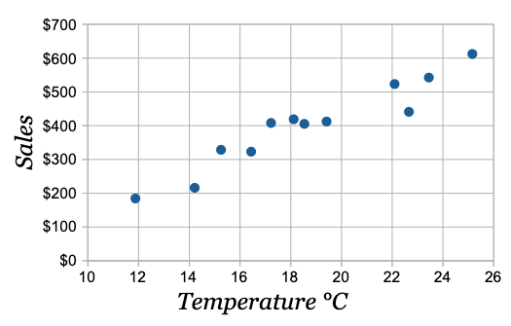

EX: estimate sales at a temperature of 21ºC?

EX: estimate temperature at sales of $150?

Sometimes our trendline isn’t linear. Consider this graph:

