Name: ______________________________________ Date: ________________________

Student Exploration: Graphing Skills

Vocabulary: bar graph, line graph, negative relationship, pie chart, positive relationship, scale, scatter plot, variable

Prior Knowledge Questions (Do these BEFORE using the Gizmo.)

- Four kinds of graphs are shown in this Gizmo. Circle the kinds you have seen before.

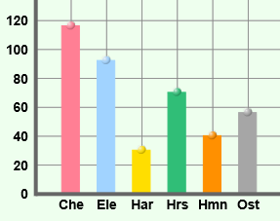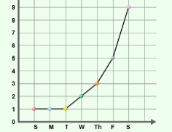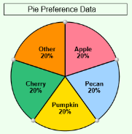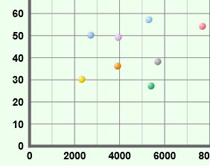

Bar graph Line graph Pie chart Scatter plot

- Why do you think graphs are useful in science?

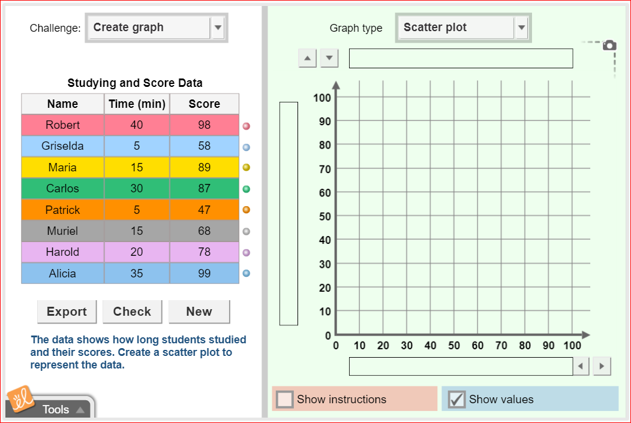

Gizmo Warm-up: Using the Graphing Skills Gizmo

- The Graphing Skills Gizmo starts with a bar graph on the right and a data set on the left. Use the Graph type dropdown list to select scatter plot. Practice using the Gizmo by doing the following:
- Try typing in a title.
- Try labeling the vertical and horizontal axes.
- Try changing the scale of the vertical axis (click up/down arrowheads top left) and of the horizontal axis (click left/right arrowheads bottom right).
  - Try dragging points from the data table to the graph.

Activity:  Scatter plots | Get the Gizmo ready:  - Under Challenge select Create graph.  - Under Graph type select Scatter plot.  - If necessary, click New until Studying and score data appears. | 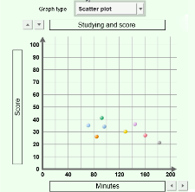

Goal: Create a scatter plot.

- Create graph: Scatter plots are used to see if one variable is related to another. Each point on a scatter plot has two values which we can write in (x, y) format. For example, if Robert studied for 40 minutes and got a quiz score of 98, Robert’s point would be placed at (40, 98) on the graph. (You can think of that as “over 40, up 98.”) To make a scatter plot, do the following:
- Write a title for the graph (can you avoid “vs” and use a sentence to indicate the relationship between the two variables being represented in the graph?).
- Label the horizontal axis based on the second column of the data table, and the vertical axis based on the third column of the data table. Include units in each label.
- Adjust the horizontal and vertical axis scales as needed so that your points will be spread across at least 2/3 of the entire grid.
- Drag each point onto the grid to match the data provided.

- Check your work: Click Check. What was your accuracy score? ______________________

- Revise: Turn on Show values on mouseover and adjust the graph until your score is 100. Adjust the axis scales as necessary.

***PAUSE HERE and take a screenshot of your completed graph and paste into a document. Save the document, as you will be uploading it to Teams!***

- Interpret: Based on this graph, write a concluding statement to answer the research question: “Will studying help you do well on a test?”. Explain by describing what type of correlation is shown on the graph. Describe the relationship between the independent variable and dependent variable.
- Extend your thinking 1: Create scatter plots of the remaining data options by clicking “NEW” to toggle though the available data tables.

  - Which scatter plot graphs in the Gizmo show a positive relationship?

  - Which scatter plot graphs in the Gizmo show a negative relationship?

6. Extend your thinking 2: In the “challenge” drop down menu, choose “create table” instead of “create graph”. Click “new” until you get to the “Gas Mileage vs Weight” scatter plot. Complete the data table from the data points in the scatter plots, complete with appropriate headings.

***PAUSE HERE and take a screenshot of your completed table and paste into a document. Save the document, as you will be uploading it to Teams!***

You have now completed this assignment. Please log into Teams and load your document with 2 screenshots, as well as images of this completed booklet into the posted assignment.

