Centimeters and Millimeters

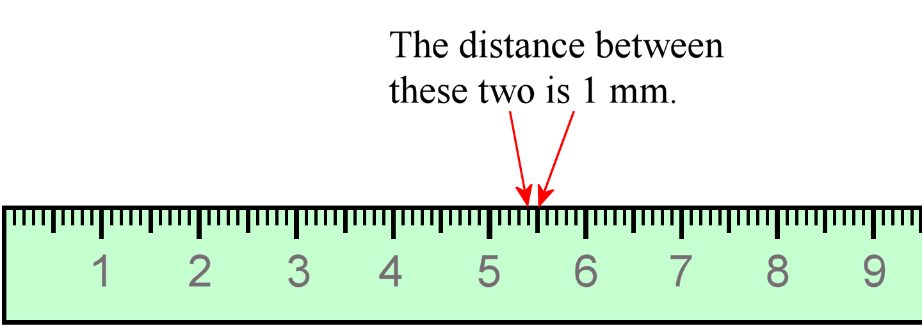
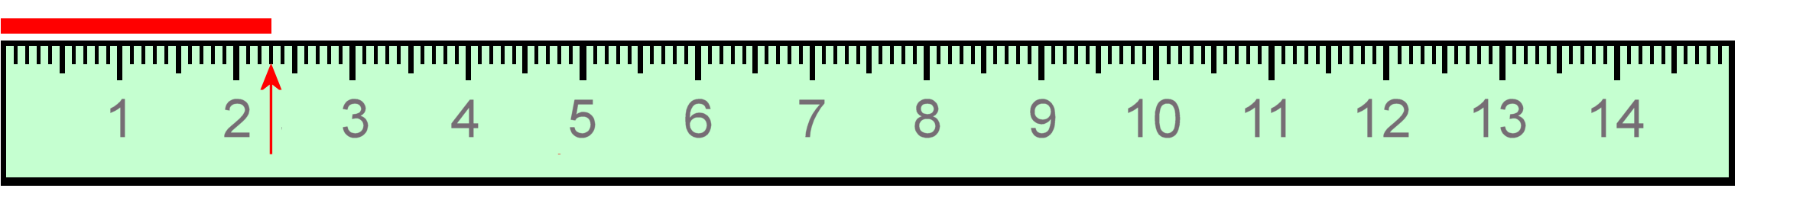
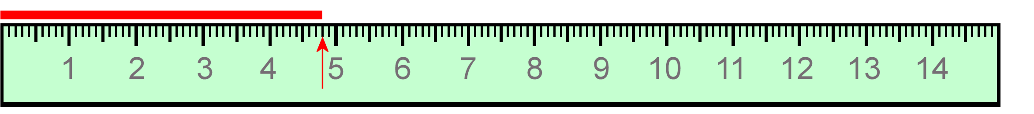
This ruler measures in centimeters.
The numbers signify whole centimeters.
All the shorter lines between those are for millimeters.
The distance from one short line to the next line is 1 millimeter. We write 1 mm. Millimeters are very tiny!
Look at the ruler: there are 10 millimeters in each centimeter.

Measuring lines: First see how many whole centimeters long the line is. Then count how many little millimeter-lines beyond that it reaches, and finally decide what your estimated digit will be by determining if it’s on a line or in-between.

This line is 2 cm 3 mm long, and directly at the line so it’s 2.30 cm. At the same time, it is 23.0 mm long. Why? Each centimeter is 10 mm, so 2 cm is 20 mm. That means 2 cm 3 mm makes 23.0 mm in total,
and we add the zero as our estimated digit because it ends at the line directly.

This line is 4.80 cm long. At the same time, it is 48.0 mm long.

- Measure the lines using the ruler, first in cm. Then write their lengths using millimeters.

  - cm = mm

  - cm = mm

  - cm = mm

  - cm = mm

  - cm = mm

  - cm = mm

- Draw lines using a ruler.
  - 7.90 cm

  - 10.50 cm

  - 14.0 mm

  - 55.0 mm

  - 96.0 mm

- Measure items you can find at home, using a centimeter-millimeter ruler. If the item’s length
does not exactly end on a marking on the ruler, remember to estimate the last digit accordingly.
Item Length

- Change between millimeters and centimeters.

a.
70.5 mm = cm 126.9 mm = cm
b.
1.27 cm = mm
45.35 cm = mm
c.
8.9 mm = cm
102.21 cm = mm

- Measure the sides of this triangle in centimeters.

Side AB cm
Side BC cm Side CA cm

