PreIBSc9 – Spindlove + Kovacevic
Measurement + Significant Digits (aka “sig figs”)

Measured Values
There are two types of quantities, those that include _______________ values and those that include _______________ values.
- _____________ values can either be counting numbers or defined values, both of which are perfect and exact.
  - Counting numbers: If Johnny has 5 loonies, he has exactly 5 and not 5.7 loonies.
  - Defined values: Values that have been created by scientists, such as 1 dozen = 12, are also said to be perfect and exact. Another example is that 1 cm = 10 mm.

- ________________ values are created by reading a measurement instrument, such as a centigram balance, a graduated cylinder or a ruler. Measured values are NOT perfect or exact.

A Few Measurement Tools:
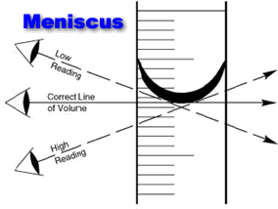 | 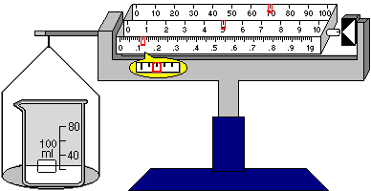
Graduated Cylinder (measures volume) | Centigram Balance (measures mass) | Ruler (measures length)
All measured values obtained from these instruments have limited precision, and those quantities must be recorded to the correct number of digits, or ___________________

___________________ (aka “_______________” in your future science courses).

When reading measured values on an instrument in the laboratory, one must decide upon how

many significant digits (or _______________________________________________________) these quantities should include, which reflects the precision of the instrument used. These values are recorded to be as accurate as possible, as well as precise.

__________________ refers to how close a value is to its true value, whereas ___________________ refers to how repeatable a measurement is.
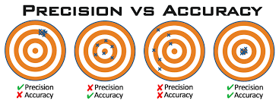
When reading measured values on an instrument, we obtain a measurement reading by using the markings (division lines, graduations, “tick lines”, partition lines, etc.) as seen on the instrument. Our measurement readings will always involve some degree of _______________, however, because the item being measured doesn’t always exactly line up with the marking/division lines on the measuring device – this is why the measurement readings must contain ________ more reasonably estimated place value than what we are certain of, called

the _______________________________.
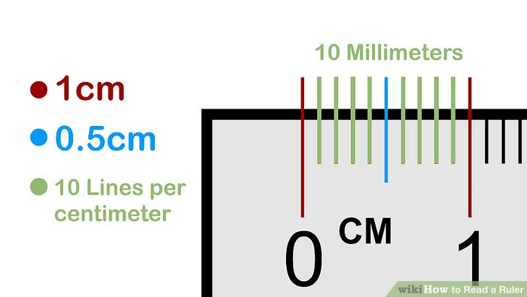

Significant Digits
Your measured values with the correct number of significant digits are thus:
- __________________________________ that contain the digits you are sure of (that correspond to the markings/division lines on the measuring device) and
- _____________________________________ (the estimated number will be one more place value than the value of the smallest marking/division line on the measuring device and needs to be reasonable!).
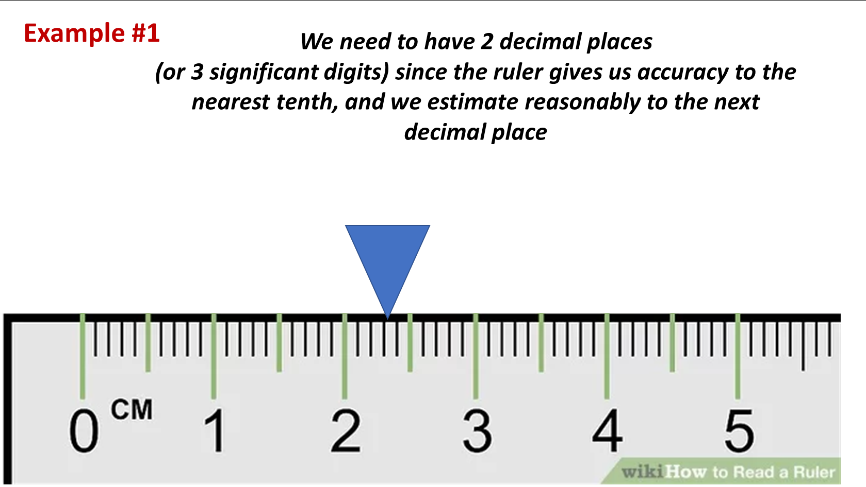

Measuring Mass
Our balances for measuring mass here at REMSS are _______________________________, meaning they provide measurement to the nearest centigram (1/100 of a gram, or 0.01 g).

How many decimal places should our mass measurements have?

