Sc9 Notes Chem Unit Name: ____________________
MULTI-VALENT COMPOUNDS + POLYATOMIC IONS
MULTI-VALENT METAL COMPOUNDS
- Many important metals are multivalent
  - “multi” means many
  - “valent” refers to the capacity to bond
- Multivalent metals can form ___________________ different __________________ ions with different ion charges
  - Ex: Iron has 2 ion charges: __________ and __________. It can exist as either.
- Periodic table shows the most ___________________ ion charge first
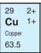
- When we’re talking about multivalent metals (ONLY!), we need make sure we’re clear which
ion form we’re talking about. To do this, we use ____________________________________
  - We ______________ use Roman Numerals for copper (Cu) because it can have a charge
of either 2+ or 1+ as an ion, and we’d need to specify which one
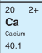
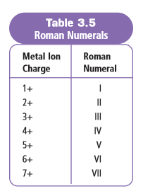
  - We _______________ use Roman Numerals for calcium (Ca) because it always has a
charge of 2+ as an ion
Examples
Fe³⁺ - Written: _____________________ ; pronounced : “iron three” ; means the iron ion has a charge of 3⁺
Fe²⁺ - Written: _____________________ ; pronounced : “iron two” and means the iron ion has a charge of 2⁺
Pb⁴⁺ - Written: _____________________ ; pronounced : “lead four” and means the lead ion has a charge of 4⁺
Cu⁺ - Written: _____________________ ; pronounced : “copper one” and means the copper ion has a charge of 1⁺
Writing Chemical Formulas with Multivalent Metals
- The _________________________ after the metal will tell you which ion charge to use
  - Example: chromium(III) fluoride ________________
Examples: Write the chemical formulas of the following compounds
- copper(I) iodide ________________  - tin(II) nitride _________________ | - iron(II) phosphide ______________  - tin(IV) nitride __________________
Naming Compounds with Multivalent Metals
- It’s important EVERY time you write the metal in the compound, you stop to _______________ if it’s multivalent!!
  - If it IS, you need to include the __________________________________
  - If it IS NOT multivalent, __________________ include Roman Numeral!
Examples: Write the name of the following compounds
- Cu₃P ________________________________
- MnO₂ ________________________________

POLYATOMIC IONS
- It is possible for some molecules (i.e. ____________________ ) to gain or lose electrons (__________________ bonding) as their atoms combine to form a molecule (___________________ bonding)
- In doing so, they become a molecular ion, called a _______________________________________.
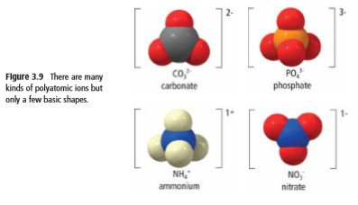
Example: Breathalyzer tests
In one type of Breathalyzer test, an orange liquid (potassium dichromate) turns green in the presence of alcohol.
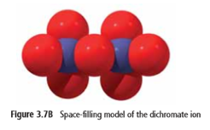
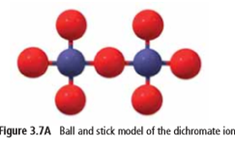
- Potassium dichromate contains ____________________________________ & ___________________________
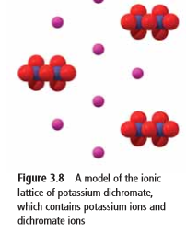
Dichromate ion has the formula Cr₂O₇²⁻
_____ atoms of chromium & ____ atoms of oxygen; has a charge of ______
The atoms oxygen and chromium are connected by ___________________ bonds to make dichromate
The negatively charged dichromate ion is connected by _________________ bonds to positive potassium ions in the potassium dichromate.

- We just learned that some molecules can _____________ or _____________ electrons to become polyatomic ions
- Because a polyatomic ion carries an electric charge, it __________________ exist on its own. It is always paired up with ions that carry an opposite charge.
- Polyatomic ions often have ___________________ names, so if you do not see the word listed as an element on the periodic table, chances are it is a polyatomic ion so refer to the table of common polyatomic ions
Part A: Writing Formulas of Compounds with Polyatomic Ions
Examples:
Sodium chromate Tin(II) hydroxide

Part B: Naming Compounds with Polyatomic Ions
Examples:
NaCH₃COO Cr(OH)₃ Ba₃(PO₃)₂

