Math 11W Spindlove Name: _____________________

**Surface Area Review**

Learning Targets:

* I can identify 3D objects (vocabulary) and their 2D nets
* I can calculate the surface area of 3D objects, showing my thought process clearly

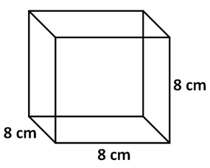

Math 11W Spindlove Name: ________________________

**Practice**



