Unit Project – 3D Measurement
Goal: to create a scaled model of an apartment, based off a blueprint design
Big Ideas:
- 3D objects are often represented and described in 2D space.
- Proportional reasoning is used to make sense of multiplicative relationships.
- Mathematics informs financial decision making.
Curricular competencies
- Model with mathematics in situational contexts
- Represent mathematical ideas in concrete, pictorial, and symbolic forms
- Connect mathematical concepts with each other, other areas, and personal interests
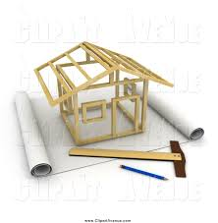
Step 1: Sketch out a floorplan for your apartment. Criteria include:
- Must have at least 1 bathroom
- Must have at least 1 bedroom
- Must have a kitchen
- Must have a living room
- Somewhere in the apartment there must be an angled wall
- Include drawings for doorways
Step 2: Decide on the real-life measurements for this.
- What is realistic? Perhaps go home and do some measuring and decide if you’d like to increase/decrease room size. How high are your ceilings? We are going to be using IMPERIAL measurements for this project as that is what the majority of building products utilize.

Step 3: Create your blueprint design for your model
- Choose a scale to use: What is the relationship you’ll use for the model (in inches) and the real-life apartment (in feet)?
- Note: the measurements on your blueprint will be the same as the model. The apartment is, of course, fictional.
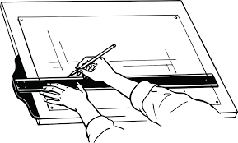
- State the scale (inches : feet) and scale ratio (converted to same unit, whole numbers, simplified)
  - Example: A model uses 5 mm to represent 1 m real life.
    - The scale is: $\frac{5 mm}{1 m}$ 5 mm : 1 m
    - The scale ratio is: $\frac{5 mm}{1000 mm}$ 1 : 200

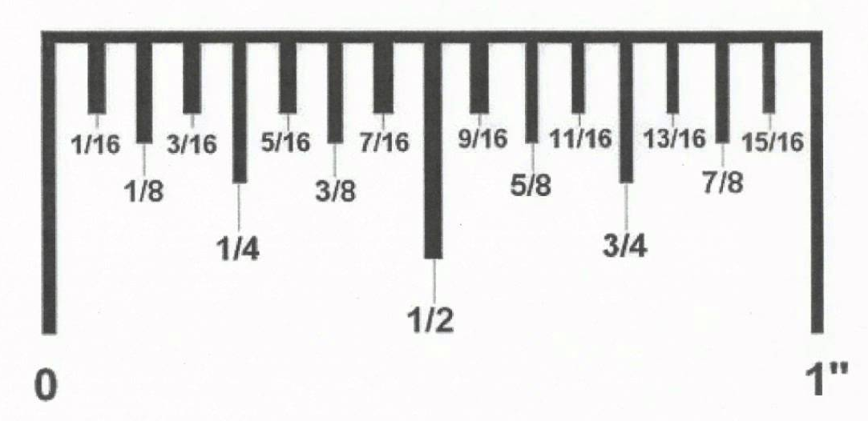
- Draw your floorplan to scale on blank paper. The floorplan represents the model’s measurements. These should be in inches. With imperial, inches use fractions of 16 instead of using a decimal.

Next to each dimension you’ve drawn to scale on your blueprint, write the corresponding dimension for what the actual building will be (in feet).

Example: (done in metric so you can’t copy my scale!)
  - Example: My model uses 5 mm to represent 1 m real life.
    - The scale is: $\frac{5 mm}{1 m}$ 5 mm : 1 m
    - The scale ratio is: $\frac{5 mm}{1000 mm}$ 1 : 200
If I decide to have a wall that is 3m long in real-life, I have to draw a blueprint with that wall’s dimension as follows:
    - $\frac{model }{actual}$ = $\frac{1 }{200}$ = $\frac{x }{3 m}$ $x=0.015m$
    - Now I need to convert that to mm….
0.015m x $\frac{1000mm }{1m}$ 15mm , So I would draw that wall on my
blueprint to be 15mm
Step 4: Build the model
- Build the 3D scaled version using the materials provided. The measurements should match your blueprint. You need to include floors and walls and doorways cut-outs. You do not include the ceiling and doors.

Step 5: Calculations
- Calculate the surface area of each type of flooring. Then use the flooring cost per square foot provided to calculate the cost of flooring for the actual apartment.
- Calculate the surface area of each wall. Then use the paint cost per square foot provided to calculate the cost of painting for the actual apartment
- Calculate the perimeter of each room. Exclude doorways! Then use the baseboard cost per linear foot provided to calculate the cost of baseboards for the actual apartment
- Calculate the volume for each room in your apartment. Obtain a total volume for your entire apartment.
- Obtain a total square footage for your entire apartment. Use the following resource to calculate the average annual cost to heat your apartment
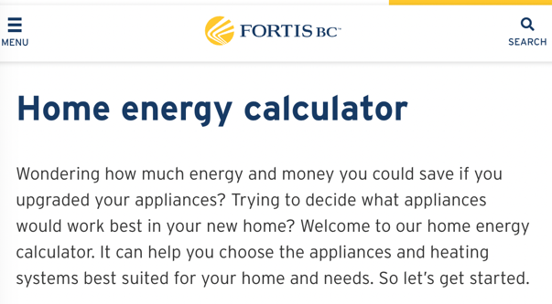

Time will be limited. You’ll have to use your class time wisely and perhaps do some work outside of class (FLEX, support block, lunch, homework..). Missing class will require you to definitely work outside of class time.

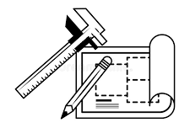
Unit Project – 3D Measurement
Goal: to create a scaled model of an apartment, based off a blueprint design
Calculations

Calculations for “Real Life” Apartment
Dimensions should all be clearly labeled on your floorplan, using imperial units (feet). Recall that feet are broken into smaller units (12 inches = 1 foot) so we use fractions of 12 instead of using a decimal.

Part A: Surface Area
Room | Surface Area Calcs | SA of room (with units)
Living Room

Kitchen

Bedroom

Bathroom

Total Surface Area of Apartment

Part B: Perimeter Be mindful of doorways, we exclude these!
Room | Perimeter Calcs | P of rooms (with units)
Living Room

Kitchen

Bedroom

Bathroom

Total measurement required for baseboards

Part C: Volume
Room | Volume Calcs | Vol of room (with units)
Living Room

Kitchen

Bedroom

Bathroom

Total Volume of Apartment
Unit Project – 3D Measurement
Goal: to create a scaled model of an apartment, based off a blueprint design
Cost of Materials

Cost of Materials for “Real Life” Apartment
.
Part A: FLOORING (based on surface area)
Room | SA of room (with units) | Flooring Choice  &  Cost per sq.ft. | Cost of Flooring of Room
Living Room

Kitchen

Bedroom

Bathroom

Total Cost of Flooring

Part B: Baseboards (based on Perimeter)
Total measurement required for baseboards | Baseboard Choice  &  Cost per linear ft. | Total Cost of Baseboards

Part C: Heating (based on square footage)
Total square footage of apartment | Use the Fortis Home Energy Calculator to compare annual costs for heating your home.  Open QR and Input the information required. Find an estimate for the following types of heating  (Menu: Appliance Home Heating)
 | Boiler – Natural Gas | Baseboard Heating – Electric | Furnace – Propane | Furnace – Natural Gas

Part D: Painting (based on SA of walls)
*criteria: at least one wall must contain a feature wall using wallpaper
*remember: we exclude doorways here!
WALLS PAINTED
Room | Surface Area of walls calcs | SA of walls in room (with units)
Living Room

Kitchen

Bedroom

Bathroom

Total SA of walls requiring painting

Paint usually is applied at 350 to 400 square feet per gallon …
How many gallons are required? Round up to the nearest gallon
Search cost per gallon for an interior paint.
$____________/gallon x ______ gallons needed = Cost of paint

FEATURE WALL(S) WALLPAPERED
Room feature is in | Surface Area of feature wall(s) | Wallpaper choice & Cost | Cost of covering feature wall(s)

