**THE SCIENTIFIC METHOD**

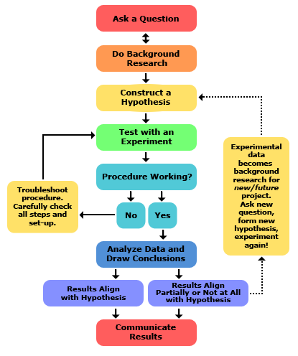

*Mnemonic device to remember it:*

The question needs to be _________________

* What effect does have on ?