LESSON – VOLUME OF PRISMS

GUIDED PRACTICE: CALCULATING VOLUME OF PRISMS

VOLUME = __________________ object occupies. Unit = __________________

Example:  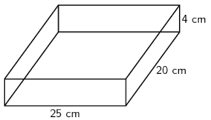  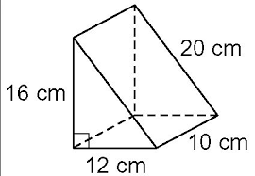 | Example:  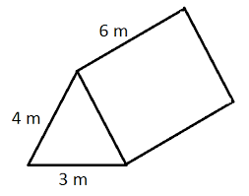

PRACTICE: CALCULATING VOLUME OF PRISMS
- TASK 1: find the volume of this classroom
- TASK 2: find the volume of your bentwood box
- TASK 3: complete the practice questions on the reverse

